PROJECT REPORT ON

## “NATURAL DIASTER WITH REFERENCE TO FLOODS IN

**MAHARASHTRA”**

BY

## BATCH T1, T2 & T3

**T.E**

UNDER THE GUIDANCE OF **MR. RATAN KAMBLE** (ASSISTANT PROFESSOR)



## ARTIFICIAL INTELLIGENCE & DATA SCIENCE DEPARTMENT

**A**.**C. PATIL COLLEGE OF ENGINEERING**

### 2024-2025

SIGNATURE: DATE: REMARK:

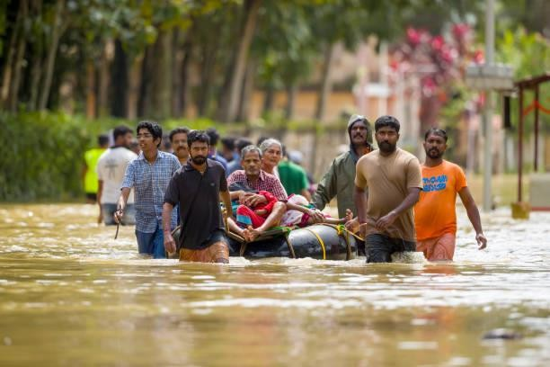

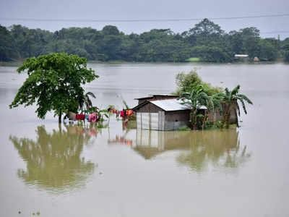

PROJECT REPORT ON

NATURAL DIASTERS WITH REFERENCE TO FLOODS IN MAHARASTRA

Submitted To:

Mr. Ratan R Kamble

Assistant Professor

Business Communication and Ethics

Project By:

|  |  |  |  |  |  |
| --- | --- | --- | --- | --- | --- |
| SR NO | Name | PRN NO | Roll number | Class | Batch |
| 1. | Samyak Bagesar | 221101060 | 03 | T.E | T1 |
| 2. | Rucha Gharve | 231102002 | 11 | T.E | T1 |
| 3. | Divyesh Potawde | 221101033 | 43 | T.E | T2 |
| 4. | Swayam Prajapati | 221101064 | 45 | T.E | T2 |
| 5. | Pareenita Shirsath | 221101062 | 52 | T.E | T3 |
| 6. | Sachin Shinde | 221101014 | 51 | T.E | T3 |
| 7. | Saniya Wagh | 221101058 | 65 | T.E | T3 |
| 8. | Renuka Wagh | 231102003 | 64 | T.E | T3 |

# 

# CERTIFICATE

This is to certify that the report on “Natural Disasters - Floods” have been successfully completed and submitted by,

|  |  |  |
| --- | --- | --- |
| Roll number | Name | PRN NO |
| 03 | Samyak Bagesar | 221101060 |
| 11 | Rucha Gharve | 231102002 |
| 43 | Divyesh Potawde | 221101033 |
| 45 | Swayam Prajapati | 221101064 |
| 52 | Pareenita Shirsath | 221101062 |
| 51 | Sachin Shinde | 221101014 |
| 65 | Saniya Wagh | 221101058 |
| 64 | Renuka Wagh | 231102003 |

A group report submitted in partial fulfilment of term work for the subject

## “BUSINESS COMMUNICATION AND ETHICS”

Approved by:

Mr. Ratan Kamble Prof.S.P.Bansu Dr.Vijaykumar Pawar (Assistant Professor) (H.O.D) (Principal)

## PREFACE

This project report is based on “NATURAL DIASTERS WITH REFERENCE TO FLOODS IN MAHARASTRA ", in which it is well explained what is Floods and its impact on environment.

Floods are a recurrent natural disaster in Maharashtra, particularly during the monsoon season, posing significant risks to life, property, and infrastructure. This report, “Natural Disasters with Reference to Floods in Maharashtra,” provides an in-depth analysis of the state’s flood management strategies, covering infrastructure development, early warning systems, and policy frameworks.

The report examines the various measures Maharashtra has implemented to mitigate flood risks, such as constructing dams, embankments, and urban drainage systems, as well as the importance of community involvement and timely communication in disaster preparedness. Additionally, it discusses the state’s policy framework and the need for a comprehensive, integrated approach to managing floods.

This document aims to offer valuable insights and lessons for policymakers, researchers, and practitioners involved in disaster management, particularly in the context of increasing climate variability and urbanization. This manuscript has been result tedious work put by our group in collecting all the possible information and compiling on this topic of research.

## ACKNOWLEDGEMENT

This is indeed a matter of great pleasure and proud privilege to be able to present this report on “NATURAL DIASTERS WITH REFERENCE TO FLOODS IN MAHARASTRA ".This manuscript would not have been possible without the go-ahead from our respected Principal Dr. Vijaykumar N Pawar.

We would like to express our gratitude and indebtedness to our Head of the Department (AI&DS) Dr. S.P. Bansu for allowing an easy access to all the facilities and encouraging us. We are heartily thankful to our teacher Mr. Ratan Kamble whose encouragement, guidance and support from the initial level to the final level, enabled us to prepare this report. Lastly we offer our regards to all those who supported us in any respect during the completion of this report.

We also wish to acknowledge the invaluable contributions of the following team members:

1. Samyak Bagesar
2. Rucha Gharve
3. Divyesh Potawde
4. Swayam Prajapati
5. Pareenita Shirsath
6. Sachin Shinde
7. Saniya Wagh
8. Renuka Wagh

Any suggestion or criticism for report will be highly acknowledged.

# 

## TABLE OF CONTENT

|  |  |  |
| --- | --- | --- |
| CHAPTER | CONTENT | PAGE NO |
|  | Preface | 5 |
|  | Acknowledgement | 6 |
|  | Abstract | 10 |
| 1 | Introduction to Natural Disaster | 11 |
| 1.1 | Natural Disaster in India | 13 |
| 1.2 | Natural Disaster in World | 14 |
| 1.3 | Types of Natural Disaster | 16 |
| 1.4 | Global Warming & Natural Disaster | 17 |
| 2 | Introduction to Flood | 19 |
| 2.1 | What is Flooding | 19 |
| 2.2 | History of Floods in Maharashtra | 20 |
| 2.3 | Types of Flood | 27 |
| 2.4 | Flood in Kerala (India) | 36 |
| 3 | Challenges & Remedies of Floods in Maharashtra | 42 |
| 3.1 | Challenges in Flood Management | 42 |
| 3.2 | Impact of Floods | 45 |
| 3.3 | Flood Economy and Responses | 47 |
| 3.4 | Flood Response Forces | 48 |
| 4 | Flood Management System in Maharashtra | 50 |
| 4.1 | Infrastructure development and maintenance | 50 |
| 4.2 | Early Warning Recovery | 53 |
| 4.3 | Policy Framework for Flood Management in Maharashtra | 55 |
| 5 | Government Policies | 59 |
| 5.1 | Disaster Management Framework | 59 |
| 5.2 | Flood Management Plans | 59 |
| 5.3 | Administrative Structure | 61 |
| 5.4 | Legislative and Governance | 63 |
| 5.5 | E-Governance Initiatives | 63 |
| 6 | Case Study | 67 |
| 6.1 | Articles | 67 |
| 6.2 | News | 70 |
| 6.3 | Interview Questions | 72 |
|  | Glossary | 74 |
|  | Glossary Index | 76 |
|  | Bibliography | 76 |

**LIST OF ILLUSTRATIONS**

|  |  |  |
| --- | --- | --- |
| Figure no. | Title | Page |
| 1.1 | Common Natural Disasters | 11 |
| 1.2 | Natural Disaster Types | 12 |
| 1.3 | Natural Disaster in India | 13 |
| 1.4 | Level of Exposure to natural Hazards | 15 |
| 1.5 | Affected People | 15 |
| 1.6 | Types of Natural Disasters | 17 |
| 1.7 | Global Warming and Natural Disasters | 18 |
| 2.1 | Mumbai Meteorological Event | 21 |
| 2.2 | Map of Flood Event | 22 |
| 2.3 | Graph of high tide | 23 |
| 2.4 | Rainfall Intensity | 23 |
| 2.5 | Liable areas of Floods in India | 24 |
| 2.6 | Percentile of Seasonal Rainfall | 26 |
| 2.7 | Freshwater Flooding | 26 |
| 2.8 | Fluvial Flood Diagram | 28 |
| 2.9 | Overview of Fluvial Flood | 28 |
| 2.10 | Losses due to Fluvial Graph | 29 |
| 2.11 | Fluvial Flood Real Image | 29 |
| 2.12 | Images of Pluvial Flood | 31 |
| 2.13 | Rainfall Intensity due to Pluvial Flood | 32 |
| 2.14 | Diagram of Pluvial Flood | 32 |
| 2.15 | Coastal Flood Diagram | 34 |
| 2.16 | Coastal Flood By 2050 | 24 |
| 2.17 | Map of Coastal Flood | 35 |
| 2.18 | Map of Kerala | 38 |
| 2.19 | Graph of Kerala Flood | 38 |
| 2.20 | Overall State Map | 39 |
| 2.21 | Images of Kerala Flood | 40 |
| 3.1 | Waterlogged Streets in Mumbai during a flood | 42 |
| 3.2 | Government officials in a meeting discussing flood response strategies | 43 |
| 3.3 | Informal Settlements in a flood-prone area | 44 |
| 3.4 | Displaced families in temporary Shelters after a flood | 45 |
| 3.5 | Environment impact of floods on a river ecosystem | 46 |
| 3.6 | Government relief efforts following a flood | 47 |
| 3.7 | NDRF Team Conducting a Rescue Operation during a Flood | 48 |
| 3.8 | India Army Personnel Assisting in Flood Operation | 49 |
| 4.1 | Mumbai Police Stands Guard Forces India | 51 |
| 4.2 | Struggle of People in Flood | 52 |
| 4.3 | Flood In Mumbai 2005 | 52 |
| 4.4 | Rescue Operation to save People Lives | 54 |
| 4.5 | Mumbai Local Train during Floods | 55 |
| 4.6 | Chiplun People Saved Lives during Flood | 56 |
| 4.7 | Maharashtra Drowned in Flood | 58 |
| 5.1 | Government Policy for Flooding areas | 60 |
| 5.2 | Govt Drafts Rehab Policy | 64 |
| 5.3 | 26 July: 13 Years since Mumbai was Flooding like never Before | 66 |
| 6.1 | Red Alert areas in Pune | 68 |
| 6.2 | Shivajinagar in Pune | 69 |
| 6.3 | News on Bombay High Court’s notice | 70 |
| 6.4 | News on flood affected areas in Balaghat | 71 |

**ABSTRACT**

Maharashtra's flood management approach combines robust infrastructure development with advanced forecasting and early warning systems. Key elements include the construction of embankments and dams, urban drainage improvements, and the use of technology for flood prediction. The strategy emphasizes proactive maintenance, community involvement in flood preparedness, and collaboration with research institutions. The state’s policy framework supports legal measures, risk assessment, and public education. Despite challenges such as climate change and rapid urbanization, continued investment and adaptive strategies are essential for strengthening resilience and reducing flood impacts.

**CHAPTER 1: INTRODUCTION TO NATURAL DISASTER**

Natural disasters are **sudden** and **catastrophic** events that occur due to natural processes of the Earth. They can have **profound impacts** on human societies, economies, and the environment, often causing extensive damage and loss of life. These events are typically beyond human control and occur unpredictably, posing significant challenges to preparedness and response efforts.

Natural disasters encompass a wide range of phenomena, each with its own unique characteristics and hazards. Common types include **earthquakes, tsunamis, hurricanes, floods, tornadoes, volcanic eruptions, and wildfires.** While their specific causes vary, natural disasters share the common element of natural forces exerting immense energy and causing widespread disruption.

The effects of natural disasters can be devastating. They can result in loss of human lives, displacement of populations, destruction of homes and infrastructure, disruption of essential services such as water and electricity, and environmental degradation. The economic impacts can be substantial, affecting local economies and even broader regional or national economies.

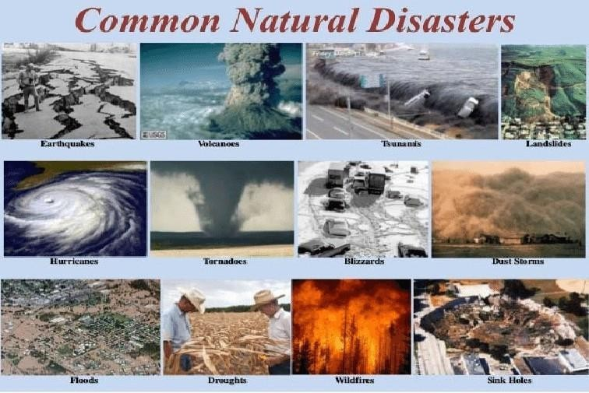

**Fig 1.1. COMMON NATURAL DISATERS**

## WHAT IS NATURAL DISASTER

Natural disasters can include phenomena such as earthquakes, hurricanes, floods, tsunamis, volcanic eruptions, tornadoes, wildfires, and more. They are typically beyond human control and occur unpredictably, posing challenges in terms of preparedness, response, and recovery efforts.

Basically A natural disaster refers to a catastrophic event that occurs due to natural processes of the Earth, typically resulting in significant disruption, damage, or loss of life and property. These events are often triggered by geological, hydrological, meteorological, or even biological phenomena. Examples include earthquakes, tsunamis, hurricanes, volcanic eruptions, floods, droughts, and wildfires.

Scientifically, natural disasters are studied to understand their causes, mechanisms, and impacts, aiming to improve prediction, mitigation, and response strategies. Research focuses on geological and climatological processes, hazard assessment, early warning systems, and strategies for reducing vulnerability and enhancing resilience to minimize the adverse effects of these events on human populations and the environment.

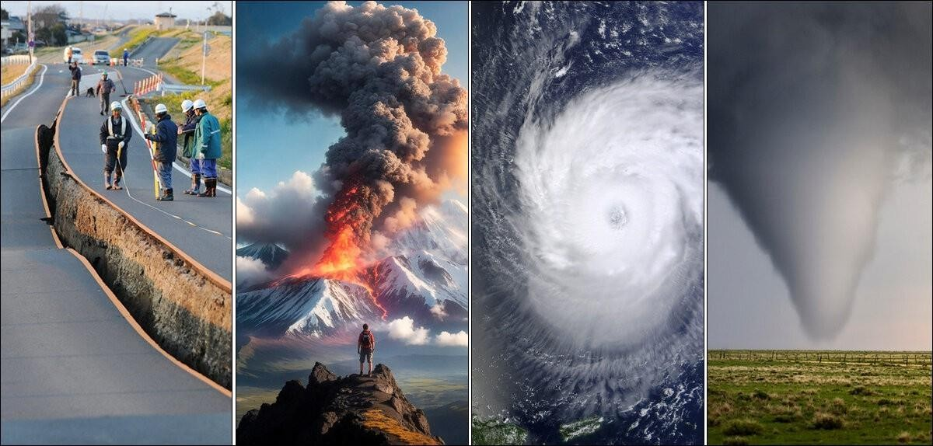

**Fig:1.2. NATURAL DISASTERS TYPES**

## 1.1 NATURAL DISASTERS IN INDIA

**India** experiences **a variety of natural disasters due to its d**i**verse geographical and climatic conditions**. These disasters include earthquakes, floods, cyclones, droughts, landslides, and tsunamis. Here's a detailed look at one of the significant natural disasters in India:

### Cyclone Fani (2019) is a classic example

Cyclone Fani originated from a low-pressure area formed over the Bay of Bengal in April 2019. It intensified rapidly into an extremely severe cyclonic storm, reaching wind speeds of up to 250 km/h.

Impact of Cyclone Fani made landfall near **Puri, Odisha, on May 3, 2019**, causing widespread devastation across Odisha, West Bengal, and parts of Andhra Pradesh. The cyclone resulted in extensive damage to infrastructure, including power lines, roads, and communication networks. Thond enhancing community resilience to cyclonic storms and other natural disaster.

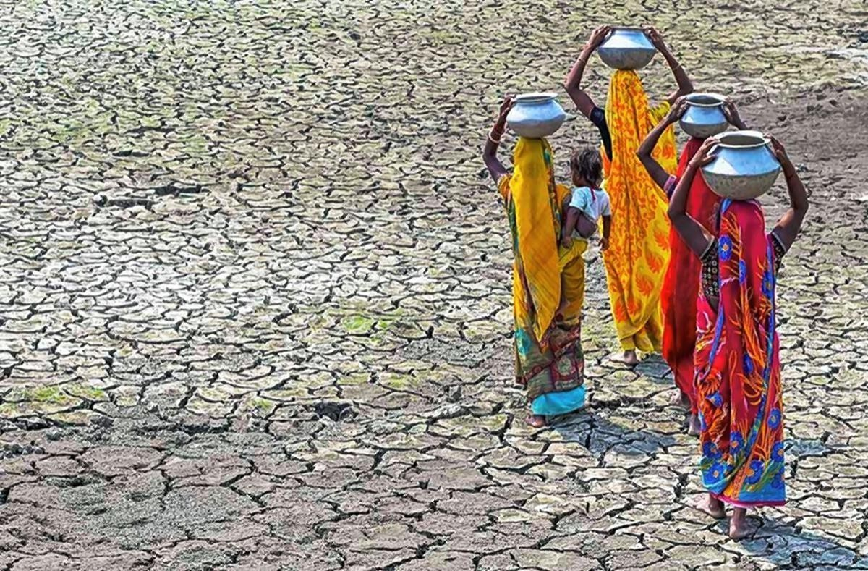

**FIG:1.3. NATURAL DISASTERS IN INDIA**

# NATURAL DISASTERS IN WORLD

Natural disasters occur globally and can have devastating effects on communities, economies, and environments. Here are some types of natural disasters with examples from around the world:

### Earthquakes

* + - Example: The 2010 Haiti earthquake was a catastrophic magnitude 7.0 earthquake that struck near Port-au-Prince, Haiti, causing widespread devastation, with estimates of over 200,000 fatalities and significant damage to infrastructure.

### Hurricanes/Typhoons/Cyclones:

* + - Example: Hurricane Katrina (2005) was one of the deadliest and costliest hurricanes in US history, causing catastrophic damage particularly in New Orleans, Louisiana, due to flooding and levee failures.

### Floods:

* + - Example: The 2011 Thailand floods were among the most severe flooding events in Thailand's history, affecting over 13 million people and causing extensive damage to agriculture, industry, and infrastructure.

### Tsunamis:

* + - * Example: The 2004 Indian Ocean tsunami, triggered by a massive undersea earthquake off the coast of Sumatra, Indonesia, resulted in waves that affected 14 countries, causing over 230,000 deaths and widespread devastation.

### Wildfires:

* + - Example: The 2019–2020 Australian bushfire season was particularly intense, with wildfires burning across large areas of Australia, destroying thousands of homes, devastating wildlife habitats, and causing significant air quality issues.

### Droughts:

* + - * Example: The ongoing drought in the Horn of Africa, affecting countries like Somalia, Ethiopia, and Kenya, has led to food shortages, loss of livestock, and humanitarian crises impacting millions of people.

### Landslides:

* + - * Example: The 2014 Oso landslide in Washington State, USA, was a devastating event where a massive landslide destroyed homes and claimed lives after heavy rainfall saturated the soil, triggering the slope failure.

These examples illustrate the diverse and widespread impact of natural disasters across different regions and climates, highlighting the importance of disaster preparedness, mitigation strategies, and international cooperation in response and recovery efforts.

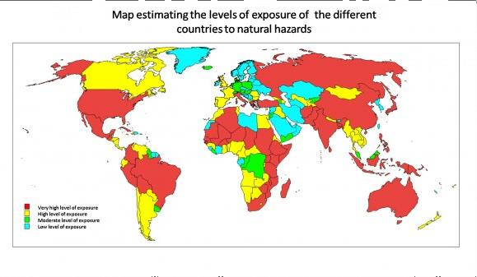

**Fig: 1.4.LEVEL OF EXPOSURE TO NATURAL HAZARDS**

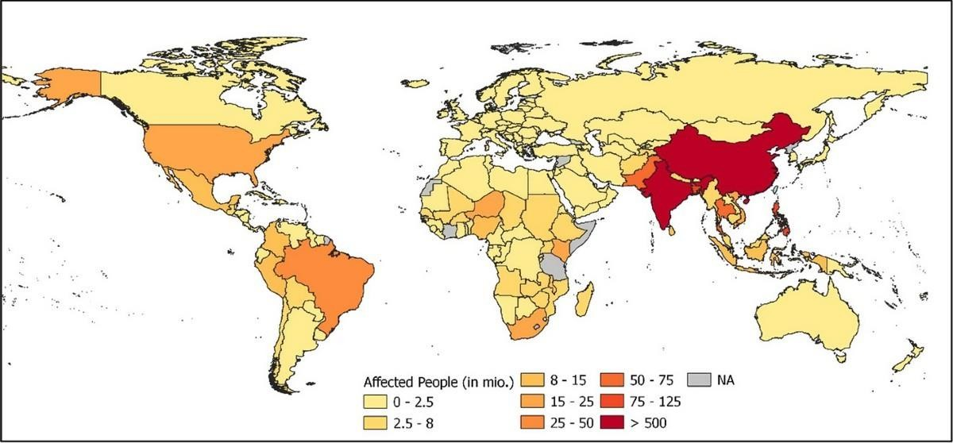

**Fig.1.5. AFFECTED PEOPLE**

# TYPES OF NATURAL DISASTERS

Natural disasters can be broadly categorized into several types based on their causes and characteristics. Here are the main types of natural disasters.

### Meteorological Disasters:

* + - * Tropical Cyclones (Hurricanes or Typhoons): Intense rotating storms with strong winds and heavy rainfall, forming over warm ocean waters.

### Hydrological Disasters:

* + - * Floods: Overflow of water onto normally dry land, caused by heavy rainfall, storm surges, or dam failures.
        + Tsunamis: Large ocean waves generated by underwater earthquakes, volcanic eruptions, or landslides.

### Climatological Disasters:

* + - * Droughts: Prolonged periods of abnormally low rainfall, leading to water shortages, crop failures, and economic impacts.
      * Heatwaves:Extended periods of excessively hot weather, often accompanied by high humidity, posing health risks.

### Biological Disasters:

- Epidemics/Pandemics: Rapid spread of infectious diseases affecting large populations, often exacerbated by factors like climate change or population density.

* + - * + Insect Infestations: Population explosions of insects (e.g., locust swarms) due to favorable environmental conditions, causing agricultural damage.

### Geomorphological Disasters:

* Landslides: Downward movement of rock, soil, and debris along slopes, triggered by factors such as heavy rainfall, earthquakes, or volcanic activity.
* Avalanches: Rapid flow of snow down a slope, often triggered by disturbances like new snowfall, wind, or human activity.

Each type of natural disaster has its own set of characteristics, causes, and impacts, requiring specific strategies for mitigation, preparedness, response, and recovery. Effective disaster management involves understanding these types, assessing risks, implementing early warning systems, and building resilience in communities and infrastructure.

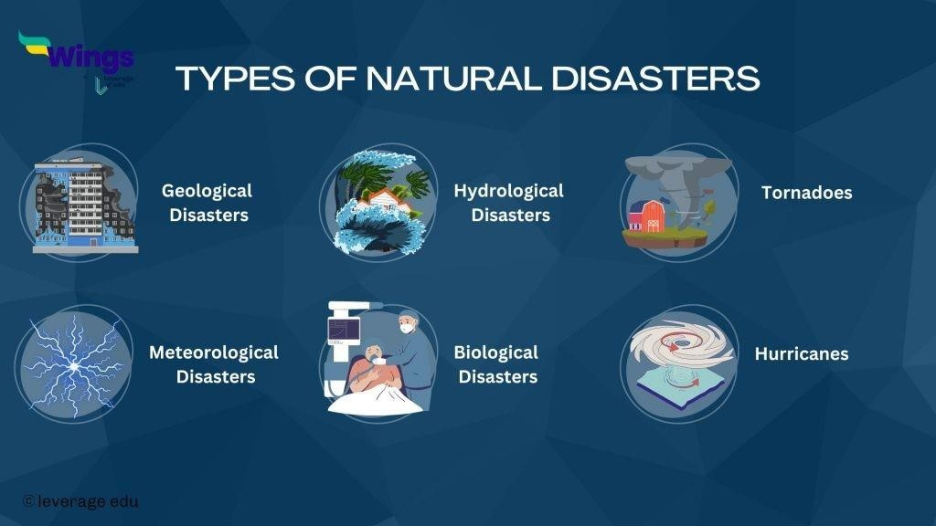

# Fig.1.6.: TYPES OF NATURAL DISASTERS

Each type of natural disaster has its own set of characteristics, causes, and impacts, requiring specific strategies for mitigation, preparedness, response, and recovery. Effective disaster management involves understanding these types, assessing risks, implementing early warning systems, and building resilience in communities and infrastructure.

# GLOBAL WARMING AND NATURAL DISASTERS

Global warming is driven primarily by human activities such as the burning of **fossil fuels and deforestation** and is profoundly impacting the frequency and intensity of natural disasters worldwide. One of the most visible effects is the **increase in extreme weather** events. Warmer temperatures in the atmosphere and oceans fuel hurricanes, typhoons, and cyclones, making them more powerful and potentially more destructive. **Heatwaves are becoming more frequent and severe, posing significant risks to human health and exacerbating conditions for wildfires.**

Additionally, global warming alters precipitation patterns, **leading to more intense rainfall** in some regions and prolonged droughts in others. These changes heighten the risk of floods and water scarcity, affecting agriculture, water supply, and ecosystems. **Rising sea levels, a direct consequence of melting glaciers and thermal expansion of**

**seawater, intensify coastal flooding during storms and high tides, threatening coastal communities and ecosystems.** Moreover, the thawing of permafrost in Arctic and mountainous regions destabilizes slopes, increasing the occurrence of landslides and rockfalls, which can damage infrastructure and endanger lives.

Beyond immediate impacts on human communities, global warming disrupts ecosystems and biodiversity. **Changes in temperature and precipitation patterns** alter habitats and migration patterns for wildlife, affecting biodiversity and ecosystem services essential for human well-being. **These interconnected effects of global warming highlight the urgent need for international cooperation to reduce greenhouse gas emissions** and implement adaptation measures to mitigate the increasing risks posed by natural disasters worldwide.

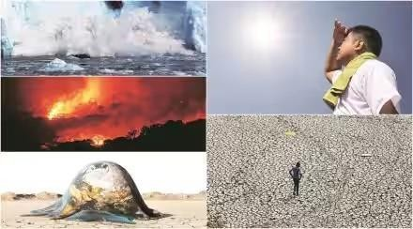

# Fig.1.7. GLOBAL WARMING AND NATURAL DISASTERS

**CHAPTER 2. INTRODUCTION TO FLOOD.**

Floods are natural phenomena, or even a disaster including an area of land that is usually dry suddenly goes underwater. If we put this in simple words a flood is an overflow of large amounts of water onto land that is normally dry. Flooding results from many events, such as overtopping of streams, rivers and lakes or oceans due to adequate rain(flooding by rains;DMC- Net)

With flooding comes the likelihood of fatalities, human suffering and widespread property damage. That is possible because flooding can automatically take with it bridges, cars and even houses including human beings. In addition, flooding can ruin the crops and able to pull away trees as well other essential part on land. Some floods, even as soon and quickly depart after few days or some take several day while other forms can last for month of more

A flood is an overflow of water that submerges land which is usually dry. The European Union (EU) Floods Directive defines a flood as a covering by water of land not normally covered by water. In the sense of “flowing water”, the word may also be applied to the inflow of the tide.

## 2.1WHAT IS FLOODING?

A flood is this: A flow of water over a land surface, substantially faster than its natural upstream river or creek. Floods may: Result from heavy rains, ocean waves coming on shore, snowmelt suddenly or dams and levees breaking Flooding poses a natural risk to life; just six inches of rapidly flowing water can knock over an adult person, and two feet will carry away most vehicles.

Flood levels above 5-6 meters are very dangerous because they inundate homes in fields..and you've read about the human incomprehension of geological history anyway... Floods can develop over weeks or within minutes, and pour out for many days to months. Floods are the most frequent and wide spread of all weather-related natural disasters.

Flash floods are the most dangerous type of flood as they combine the force and destruction capability of a flood with speed. Heavy rain begins to fall, and flash flooding will ensue when the ground has very little capacity left in it. They also occur when water

## HISTORY OF FLOOD IN MAHARASHTRA:

### Mumbai’s Meteorological Event of 26th July, 2005:

The Mumbai floods of July 26, 2005, stand as one of the maximum sizable herbal screw ups within the records of India's monetary capital. The deluge added the bustling town to a standstill, inflicting widespread devastation and highlighting the vulnerabilities of urban infrastructure within the face of severe weather activities. This essay presents a detailed account of the causes, impact, reaction, and long-time period implications of the 2005 Mumbai floods, followed via relevant graphs and information.

## CAUSES FOR SPECIFICALLY MUMBAI EVENT:

### Geographical and Environmental Factors Of Unprecedented Rainfall:

On July 26, 2005, Mumbai experienced an extraordinary 944 mm of rainfall within 24 hours, the highest ever recorded in the city in a single day and nearly half of the average seasonal rainfall. This intense rainfall, combined with Mumbai's unique topography of low-lying areas and a coastline, predisposed the city to severe flooding. The situation was exacerbated by the destruction of natural water bodies and green spaces due to rapid urbanization, which significantly reduced the city's capacity to absorb rainwater.

### Inadequate Drainage System:

The swift growth of urban areas, along with inadequate planning, resulted in the building of structures and infrastructure on natural drainage routes and wetlands. This greatly obstructed the movement of excess rainwater, causing serious waterlogging issues. The drainage system of the city, created during the British colonial era, was not capable of managing such a large volume of water. Invasions into drainage channels and the blockage of stormwater drains worsened the problem.

## IMPACT OF THE FLOOD:

**Human Casualties:** The floods resulted in the deaths of over 1,000 people, with many losing their lives to drowning, electrocution, and landslides. Approximately 500 people were reported missing, and thousands were injured.

**Economic Loss:** The financial impact of the floods was immense, with estimated losses amounting to around ₹5,500 crores (approximately $1.2 billion at that time). Businesses, residential properties, and public infrastructure suffered extensive damage.

**Infrastructure Damage:** Mumbai’s transport network, including roads, bridges, railway lines, and the airport, was heavily damaged. The city's lifeline, the local train service, was disrupted for several days, affecting millions of commuters.

**Health Crisis:** The floods led to the outbreak of waterborne diseases such as leptospirosis, gastroenteritis, and cholera. Hospitals were overwhelmed with patients, and the public health system was stretched to its limits.

**Displacement and Humanitarian Crisis:** Thousands of residents, particularly in low- lying slum areas, were displaced from their homes. Relief camps were set up to provide shelter, food, and medical aid to the affected population.

## RESPONSE TO THE DISASTER:

### Rescue and Relief Operations:

The Indian Army, Navy, and Air Force were mobilized to assist in rescue and relief operations. Local authorities, along with non-governmental organizations (NGOs) and volunteers, played a crucial role in providing immediate assistance.

### Restoration of Services:

Efforts were made to restore essential services, including electricity, water supply, and public transport, as quickly as possible. Debris was cleared, and temporary shelters were set up for those displaced by the floods.

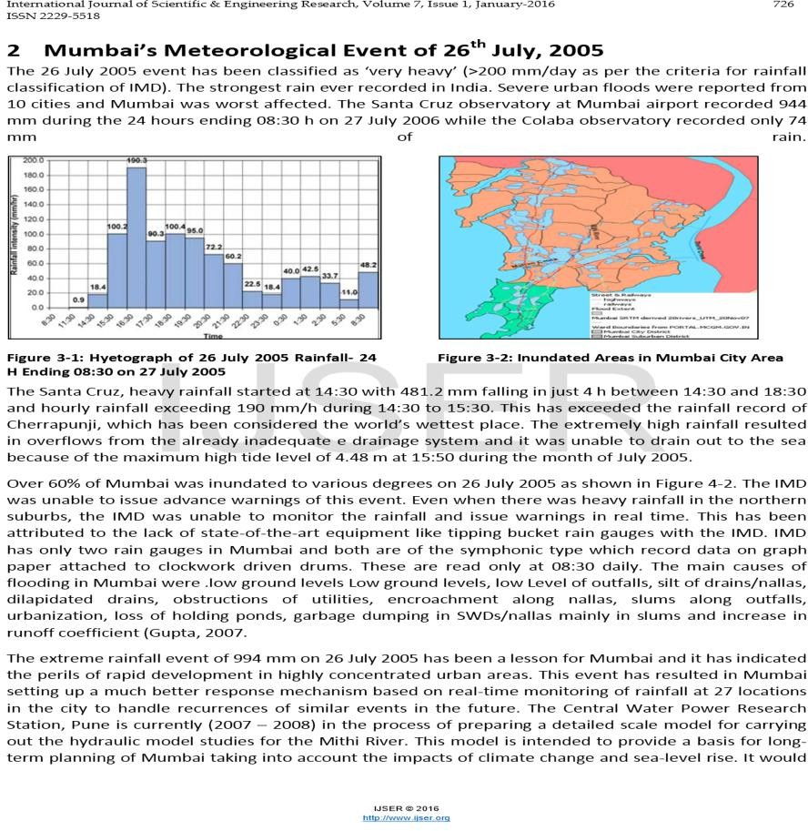 **Fig.2.1.MUMBAI METEROLOGICAL EVENT**

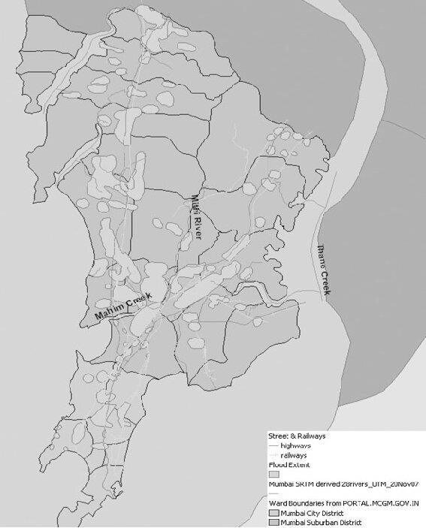

**Fig.2.2.MAP OF FLOOD EVENT**

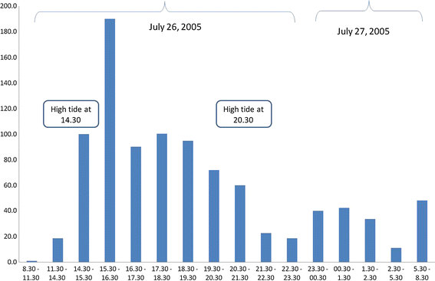

**Fig.2.3.GRAPH OF HIGH TIDE**

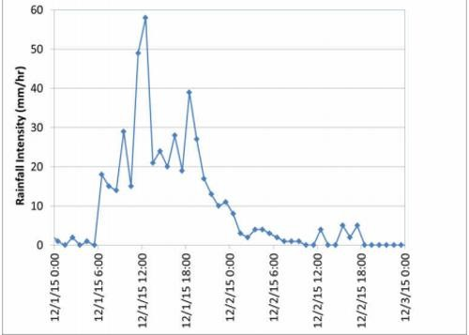

**Fig.2.4.RAINFALL INTENSITY**

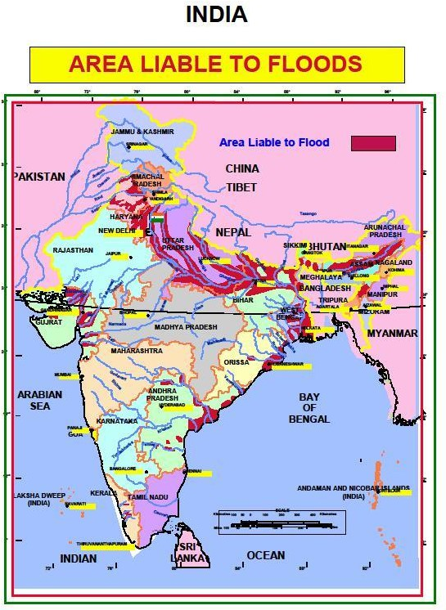

**Fig.2.5.LIABLE AREAS OF FLOODS IN INDIA**

## 2.2.2 .PUNE FLOOD IN AUGUST 2019:

The Pune floods of August 2019 were a significant natural disaster that had far-reaching impacts on the city and its surrounding areas. This essay provides an in-depth analysis of the causes, impact, response, and long-term implications of the 2019 Pune floods, detailing the events and lessons learned from this calamity.

## CAUSES OF THE FLOOD:-

### Heavy Rainfall:

The primary cause of the Pune floods was the intense and continuous rainfall over the region. In August 2019, Pune experienced unprecedented rainfall, with certain areas receiving over 200 mm of rain in just 24 hours. The heavy downpour overwhelmed the existing drainage systems, leading to widespread waterlogging and flooding.Pune's topography, with several rivers and streams flowing through the city, contributed to the flooding. The Mutha, Mula, and Pavana rivers, which flow through Pune, swelled due to the excessive rainfall, inundating low-lying areas.

### Urbanization and Infrastructure:

Rapid urbanization in Pune had led to the encroachment of riverbanks and the reduction of green cover. The construction of buildings and infrastructure on natural water channels impeded the flow of rainwater, exacerbating the flood situation.The city’s drainage infrastructure was inadequate to handle the volume of water. Blocked stormwater drains and poor maintenance further reduced the system's capacity to drain excess water efficiently.

## RESPONSE TO THE DISASTER:-

### Rescue and Relief Operations:

The National Disaster Response Force (NDRF), along with the Indian Army and local authorities, conducted extensive rescue and relief operations. Boats and helicopters were used to rescue people stranded in flooded areas.

### Restoration of Services:

Efforts were made to restore essential services, including electricity, water supply, and transportation, as quickly as possible. The municipal corporation and various agencies worked tirelessly to clear debris and unclog drains.

### Government and Policy Response:

The government announced financial aid and compensation for the affected families. Policy measures were taken to improve the city's drainage and flood management systems to prevent future occurrences.

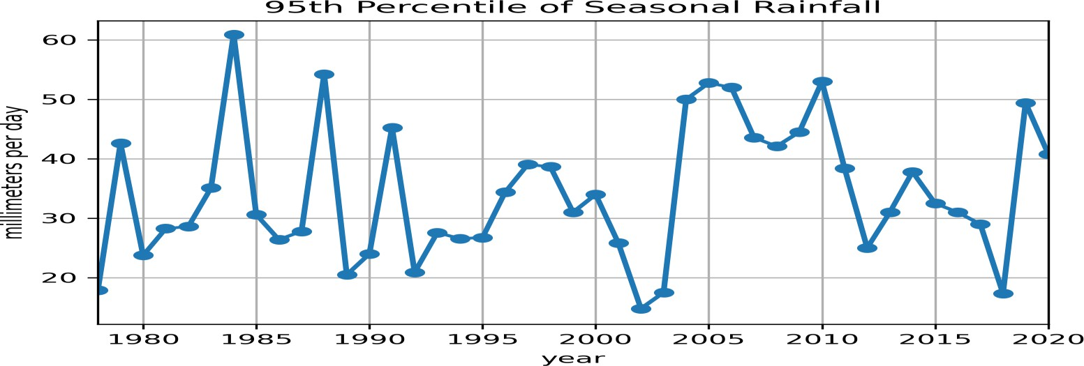

**Fig.2.6.PERCENTILE OF SEASONAL RAINFALL**

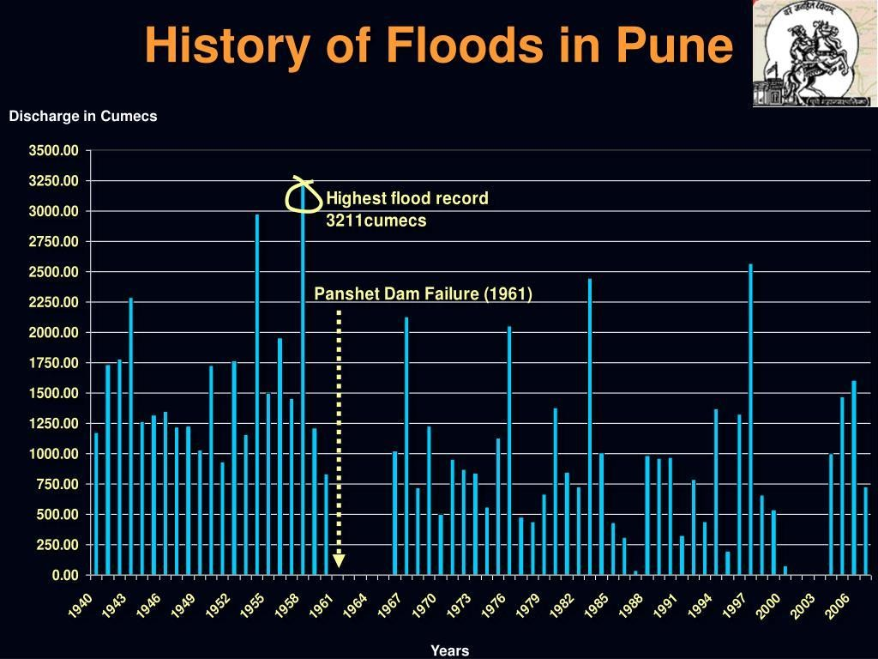

**Fig 2.7. FRESHWATER FLOODING**

# TYPES OF FLOOD

### Fluvial floods (river floods):

A fluvial, or river flood, occurs when the water level in a river, lake or stream rises and overflows onto the neighboring land. The water level rise of the river could be due to excessive rain or snowmelt.Damage from flooding can be widespread because the flow of water can affect small rivers downstream, causing dams and levees to fail and inundate nearby areas. Rainfall and precipitation, runoff, terrain and terrain are forecast. Other factors include soil saturation and the impact of climate change on the duration and intensity of rainfall. In flat areas, floods tend to rise gradually to higher and shallower areas, but can often last for several days.

**Benefits and effects of floods:** Floods in an economic activity area can have many negative effects. The extent of the impact depends on the capacity of the water and the population, and the frequency, intensity and size of the floods. Some of these factors include loss of life and property, loss of livelihoods, reduced purchasing power and productivity, mass migration, mental health, economic growth and development, and political influence (APFM, n.d.).

**Assessment:** Floods are an important part of natural water management. These are the principles of water; they wash pollutants and sediments from the river network. It is also natural for rivers to overflow their banks to a greater or lesser extent and to become flooded. Floods can therefore cause property and life loss in many communities. While there is currently no evidence of an increase in the frequency or severity of floods worldwide, the areas exposed to floods are increasing and therefore becoming more vulnerable. As a result, in recent years, there has been a great deal of violence, with such events causing death and destruction in all countries (GWP, 2013). Flooding is efficient and cannot be completely controlled. This approach aims to minimize flood losses, maximize the use of flood waters and reduce life expectancy, in line with the overall goal of maximum flood management (APFM, 2020).

**Integrated Flood Management (IFM)** is a process that promotes an integrated approach to flood management rather than a proportional approach. The efficient use of floods integrates the development of land and water in rivers within an integrated management framework, with attention to minimizing loss of life and property. IFM should encourage participation at all levels, such as integrated water management, from users, planners and decision-makers. The approach should be open, transparent, inclusive and communication should require fair decision-making; IFM calls for a change in the ethical framework to encourage efficient use of water resources and the use of strategies that manage or increase flood risk while providing protection against losses from floods (APFM, n.d.).

**Health impacts, including (river) floods:** Floods are one of the most dangerous. The health impacts of floods are wide and significant, including deaths and injuries from injuries and drowning, infectious diseases and mental health problems (acute and chronic). While some of these benefits are easy to track, the impact of climate change on humans remains unknown. For example, it is reported that two-thirds of those who died from floods died from drowning, and

two-thirds from physical injuries, heart disease, electric shock, carbon monoxide poiso2n7ing and fire. In general, only deaths directly related to floods are recorded (WHO, 2013).

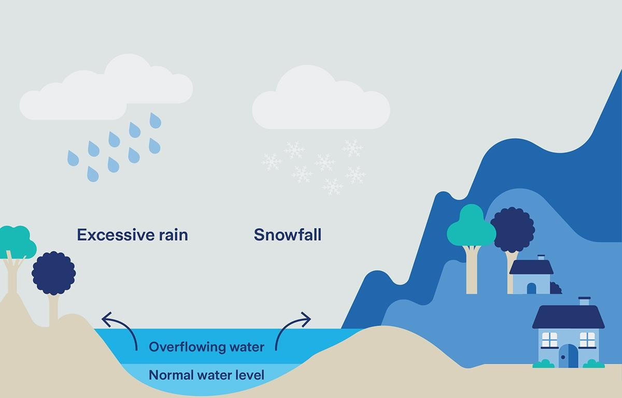

**Fig 2.8.FLUVIAL FLOOD DIAGRAM**

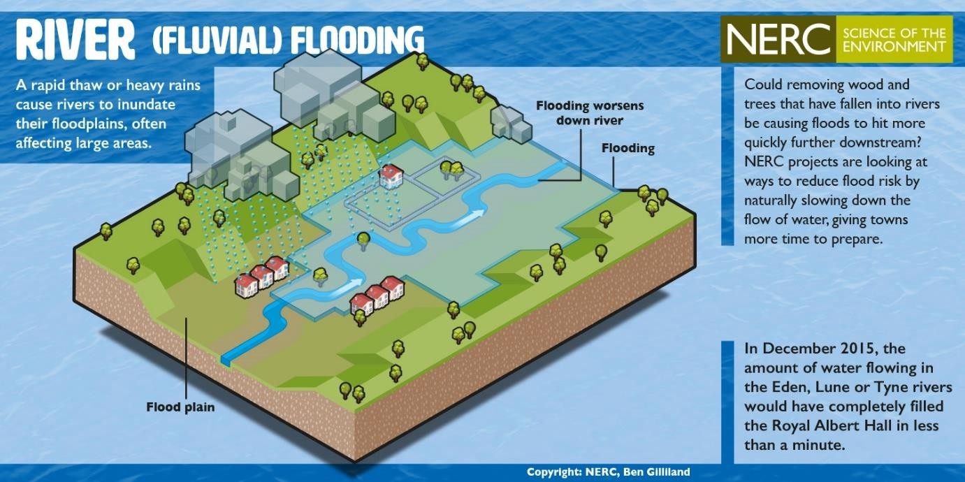

**Fig 2.9.OVERVIEW OF FLUVIAL FLOOD**

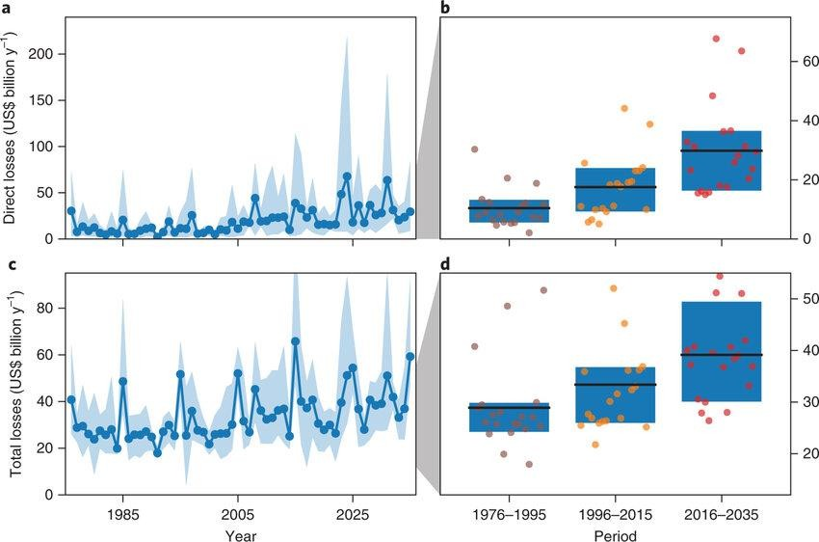

**Fig 2.10.LOSSES DUE TO FLUVIAL FLOOD GRAPH**

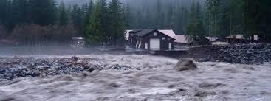

**Fig 2.11.FLUVIAL FLOOD REAL IMAGE**

* + 1. **PLUVIAL FLOODS(flash floods and surface water):**

Stormwater occurs when there is a large amount of rain that causes flooding without physical drainage. A common misconception about flooding is that you have to live near a body of water to be at risk. However, storms can occur anywhere, whether in urban or rural areas, or even in areas with no nearby water and car flooding.

Storm Flooding: Threats from Above

## TYPES OF PLUVIAL FLOODS:

### Surface Flooding:

Surface flooding occurs when city sewers fill up and water flows onto streets and nearby buildings. It happens gradually, giving people time to get to safety, and the water is usually shallow (rarely more than 3 feet deep). It is not life-threatening, but it can cause serious damage.

They are caused by short-term heavy rainfall in nearby or adjacent areas. Floods can also occur due to the sudden release of water from streams or lakes. They can be very dangerous and destructive, not only because of the force of the water, but also because of the rapid debris that often collects in the available water.

### Flash floods:

Flash floods are characterized by an intense, high velocity torrent of water. They are triggered by torrential rain falling within a short amount of time within the vicinity or on nearby elevated terrain.

Flash floods can also be caused by a sudden release of water from an upstream levee or a dam. They can be very dangerous and destructive, not only because of the force of the water, but also the hurtling debris that is often swept up in the flow.

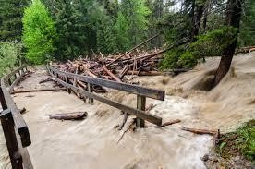 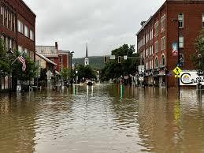

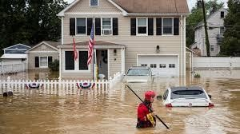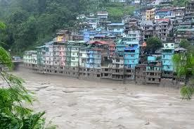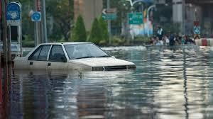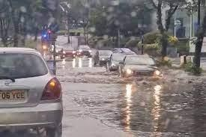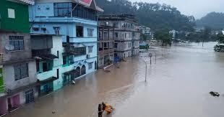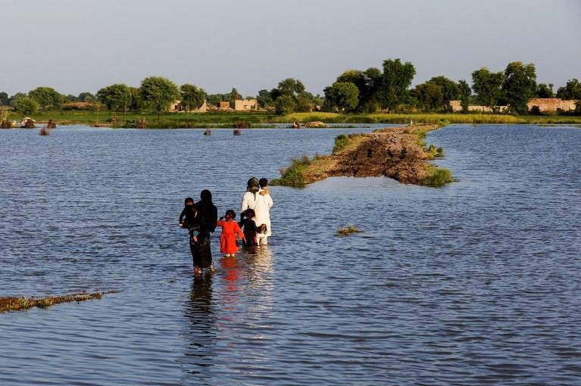

**Fig 2.12.IMAGES OF PLUVIAL FLOOD**

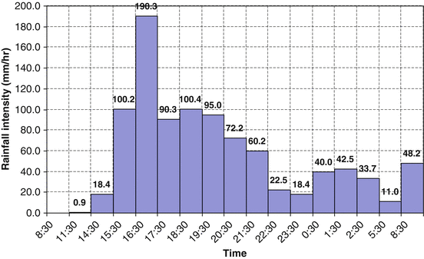

**Fig 2.13.RAINFALL INTENSITY DUE TO PLUVIAL FLOOD**

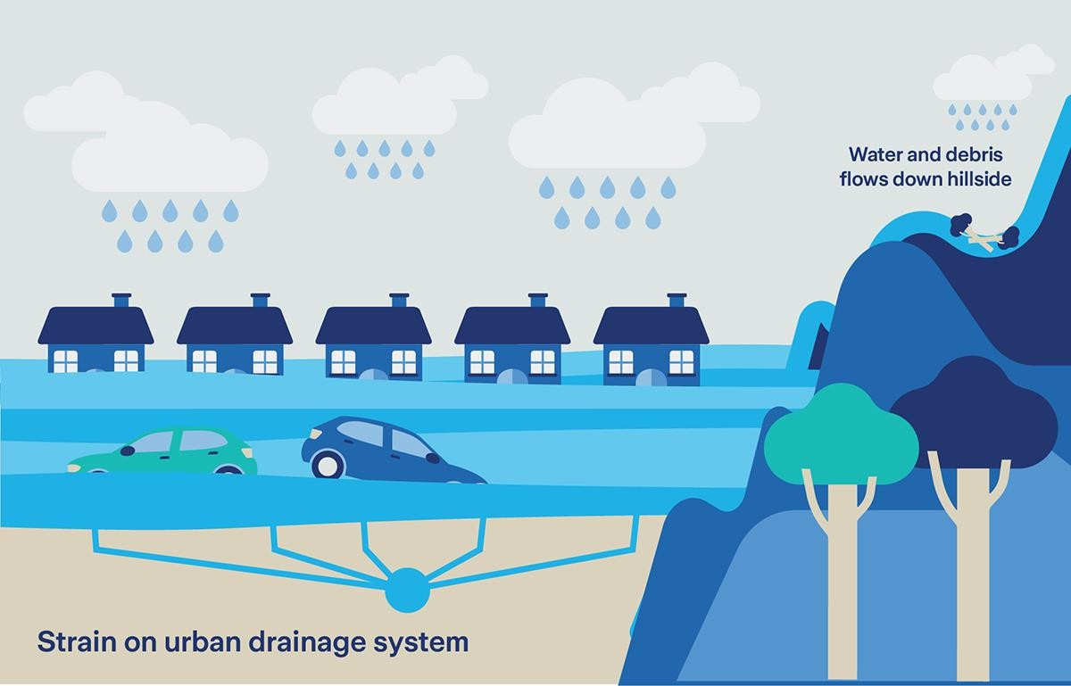

**Fig 2.14.DIAGRAM OF PLUVIAL FLOOD**

## COASTAL FLOOD (STORM SURGE):

Coastal flooding is the inundation of land along the coast by seawater. It is usually caused by intense windstorm events – particularly when they coincide with high tide – that create a storm surge. But coastal flooding can also be caused by tsunamis.

Infographic Coastal floods and storm surge

Storm surge occurs when high winds from a windstorm force water onshore and it is often the greatest threat associated with a hurricane or typhoon. The impact is dependent on the tide. Windstorms that occur during high tide can result in storm surge floods that overwhelm low-lying land and cause devastating loss of life and property.

Coastal flooding can have serious consequences from drownings and injuries to contaminated-water-caused sicknesses to mental health problems. Some of these include mental health issues caused by stress during the flooding, injuries while attempting to escape from the water or from falling debris, respiratory illness due to damp environments that can lead to mold damage, and coming into contact with contaminated flood water.

## THERE ARE THREE LEVELS OF COASTAL FLOODING:

**Minor:** Low likelihood of property damage and not directly life-threatening **Moderate:** Elevated likelihood of property damage and possibly life-threatening **Major:** Significant likelihood of property damage and seriously life-threatening

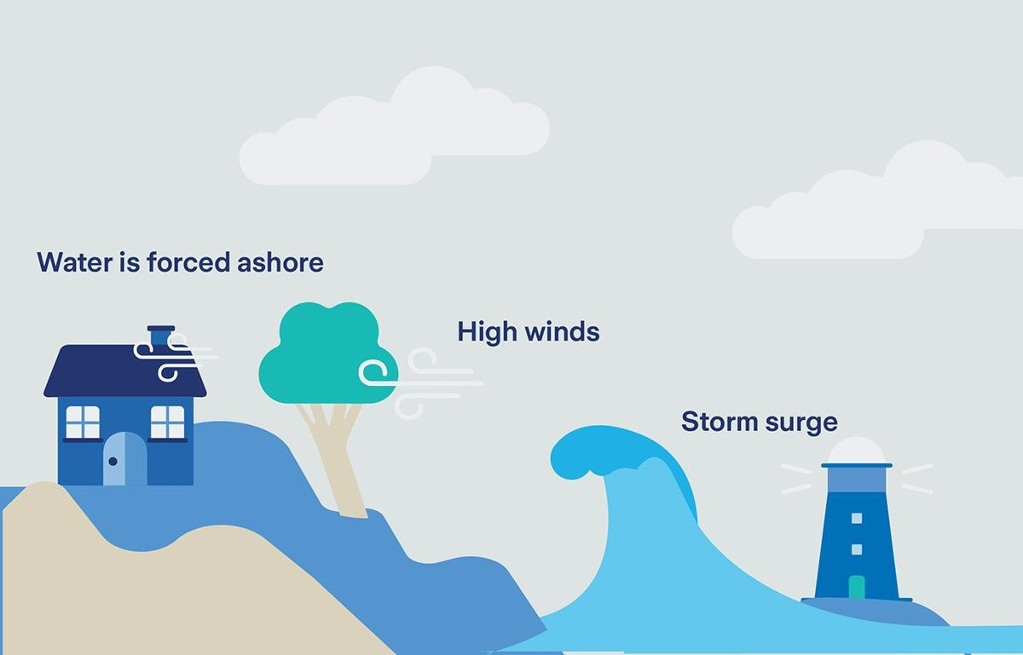

**Fig 2.15.COASTAL FLOOD DIAGRAM**

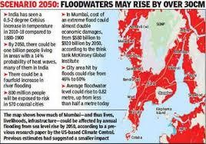

**Fig 2.16.COASTAL FLOOD BY 2050**

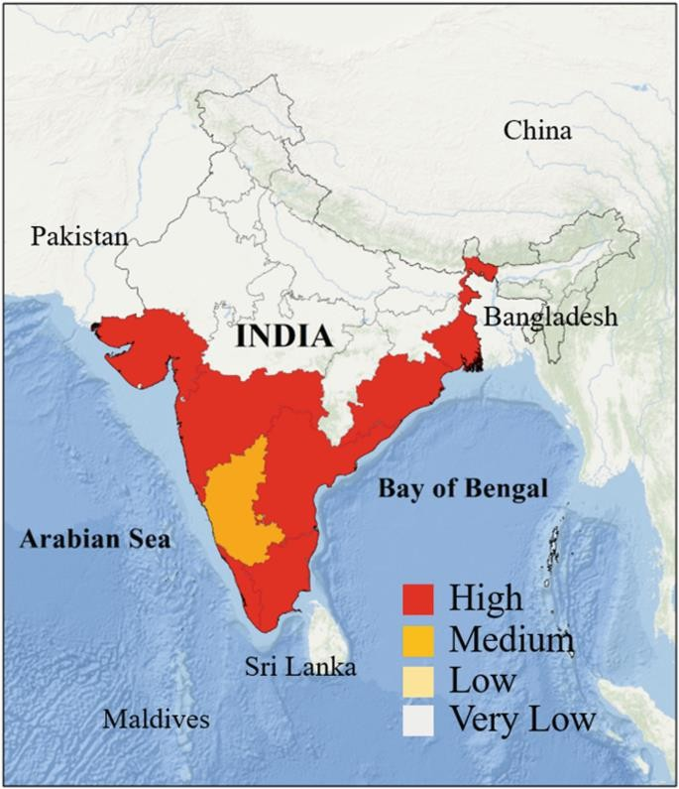

**Fig.2.17.MAP OF COASTAL FLOOD**

## FLOOD IN KERALA (INDIA) INTRODUCTION:

The state of Kerala, located in the southern part of India, experienced one of the most devastating floods in its history in 2018. The deluge resulted in massive destruction, affecting millions of people and causing significant economic losses. This essay provides a comprehensive analysis of the Kerala floods, covering their causes, impacts, and the response measures undertaken. The report also emphasizes the importance of preparedness and sustainable development to mitigate future disasters.

## CAUSES OF THE KERALA FLOODS:

The primary causes of the 2018 Kerala floods were a combination of intense monsoon rainfall and poor water management practices.

**Heavy Rainfall:** Kerala experienced unusually heavy monsoon rains in July and August 2018. The state received 42% more rainfall than usual, with some regions witnessing rainfall up to three times the average. This unprecedented downpour overwhelmed rivers, reservoirs, and dams, leading to widespread flooding.

**Release of Water from Dams:** The heavy rainfall forced the state authorities to release water from several dams simultaneously. The opening of shutters of dams like the Idukki, Idamalayar, and Mullaperiyar exacerbated the flooding situation. The sudden release of large volumes of water into already swollen rivers led to flash floods in many areas.

**Geographic and Topographic Factors:** Kerala’s unique topography, characterized by steep slopes and narrow river basins, also contributed to the severity of the floods. The hilly terrain facilitated rapid runoff, causing rivers to swell quickly and inundate low-lying areas.

**Human Activities:** Deforestation, unplanned urbanization, and illegal construction in floodplains disrupted the natural flow of water and reduced the land's capacity to absorb rainwater. These activities exacerbated the impact of the floods, turning what could have been manageable into a catastrophic event.

## LESSONS LEARNED AND FUTURE PREPAREDNESS:

The 2018 Kerala floods underscored the need for better disaster preparedness and sustainable development practices to mitigate the impact of such events in the future.

**Improved Water Management:** Effective water management practices, including timely release of water from dams and better coordination among authorities, are crucial to prevent similar disasters. Establishing a comprehensive flood forecasting and warning system can provide early alerts and help in timely evacuation and preparedness.

**Sustainable Development**: Promoting sustainable development practices, such as afforestation, proper land use planning, and restricting construction in flood-prone areas, can reduce the vulnerability to floods. Environmental conservation and restoration of natural water bodies can enhance the land’s capacity to absorb and manage excess rainwater.

**Community Awareness and Education:** Enhancing community awareness and education about flood risks and preparedness measures is essential. Conducting regular drills, training programs, and public awareness campaigns can empower communities to respond effectively in the event of a disaster.

**Strengthening Infrastructure:** Building resilient infrastructure that can withstand extreme weather events is vital. Investing in flood-resistant buildings, robust drainage systems, and reinforced roads and bridges can minimize damage and ensure quicker recovery post-disaster.

## CONCLUSION:

The 2018 Kerala floods were a stark reminder of the devastating impact of natural disasters and the importance of preparedness and sustainable development. While the immediate response to the floods showcased remarkable resilience and solidarity, long- term measures are essential to mitigate future risks. By adopting comprehensive water management practices, promoting sustainable development, and enhancing community awareness, Kerala can build a more resilient future and reduce the vulnerability to similar disasters.

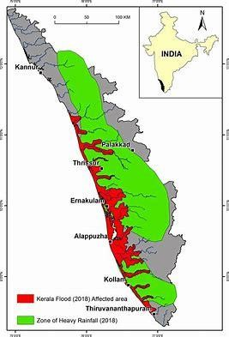

**Fig 2.18.MAP OF KERALA**

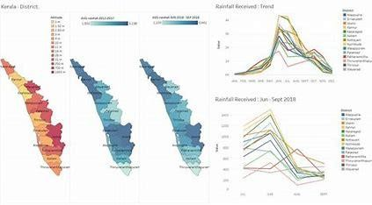

**Fig 2.19.GRAPH OF KERALA FLOOD**

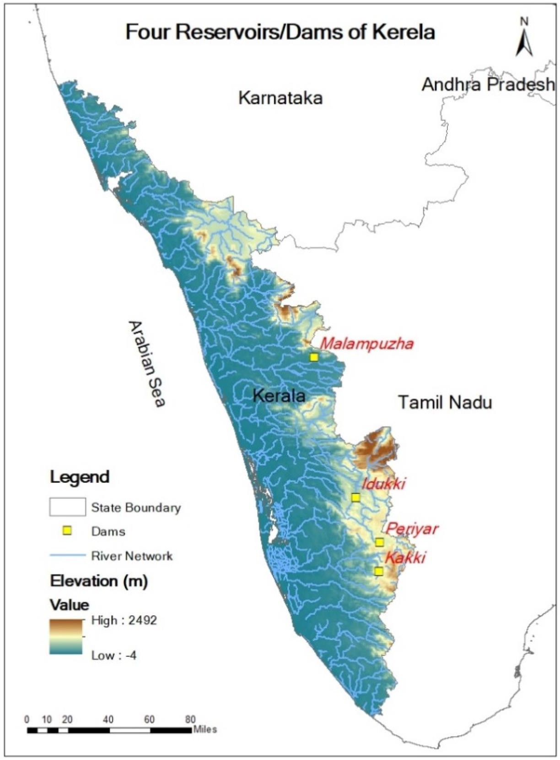

**Fig 2.20.OVERALL STATE MAP**

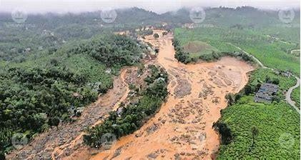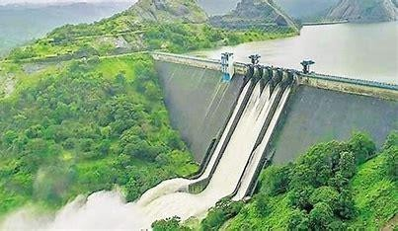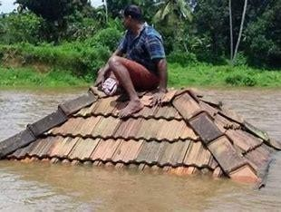

**Fig 2.21.IMAGES OF KERALA FLOOD**

**PLAGARISM REPORT:**

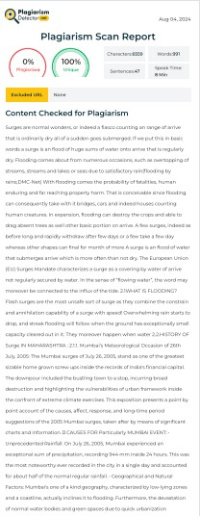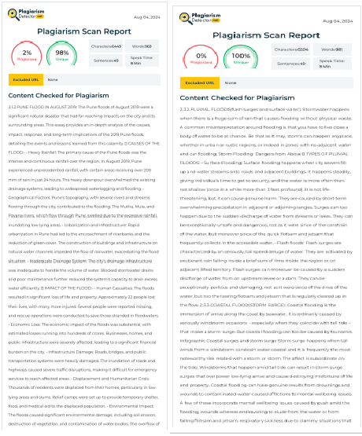

# CHAPTER 3: CHALLENGES AND REMEDIES OF FLOODS IN MAHARASHTRA

### Challenges in Flood Management

Flood management in Maharashtra faces numerous challenges that hinder effective prevention and mitigation. These challenges can be categorized into infrastructural, administrative, financial, and community-based issues.

### Infrastructural Challenges Inadequate Drainage Systems:

Many urban areas in Maharashtra, particularly Mumbai, have outdated and insufficient drainage systems. These systems are not equipped to handle the heavy rainfall that the region often experiences during the monsoon season. The lack of proper drainage leads to severe waterlogging and flooding, disrupting daily life and causing significant damage.

### Encroachment on Water Bodies:

Unauthorized construction on riverbanks, floodplains, and wetlands reduces the natural capacity of these areas to absorb floodwaters. Urbanization has led to the conversion of many natural water bodies into residential and commercial areas, exacerbating the risk of flooding.

### Aging Infrastructure:

Dams, levees, and embankments in some regions of Maharashtra are old and require urgent maintenance or upgrading. Many of these structures were built decades ago and are not designed to handle the increased volume and intensity of rainfall seen today.

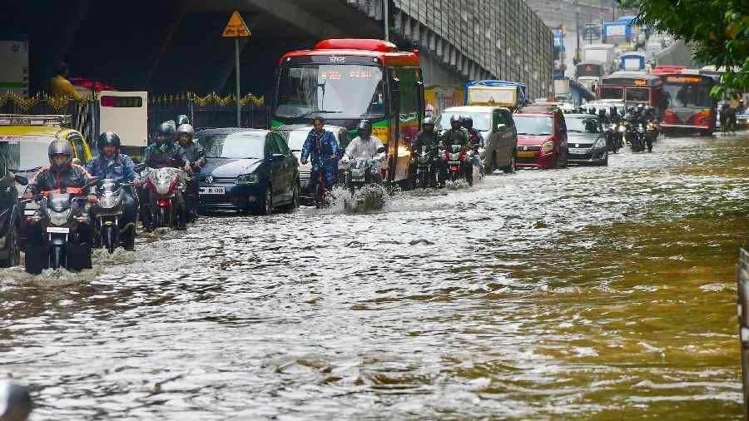

## FIG 3.1: WATERLOGGED STREETS IN MUMBAI DURING A FLOOD

### Administrative Challenges

**Coordination Between Agencies:**

Effective flood management requires seamless coordination between various governmental departments and agencies. However, there is often a lack of communication and collaboration, leading to fragmented and inefficient responses to flood situations.

### Policy Implementation:

Despite having policies and plans in place for flood management, the implementation at the ground level is frequently inefficient and inconsistent. Local authorities may lack the resources or capacity to enforce these policies effectively.

### Data and Information Sharing:

Inadequate sharing of data and information between agencies hampers effective flood forecasting and early warning dissemination. Real-time data on weather patterns, river levels, and other critical factors are essential for timely and accurate flood warnings.

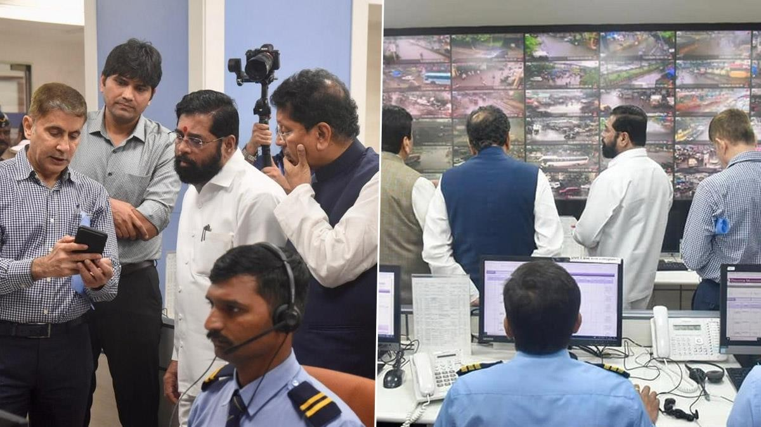

## FIG 3.2: GOVERNMENT OFFICIALS IN A MEETING DISCUSSING FLOOD RESPONSE STRATEGIES

### Community-Based Challenges

**Public Awareness and Preparedness:**

Lack of awareness and preparedness among communities about flood risks and response measures exacerbates the impact of floods. Many residents of flood-prone areas are unaware of the steps they can take to protect themselves and their property.

### Migration and Informal Settlements:

High rates of migration to urban areas lead to the growth of informal settlements in vulnerable zones, increasing the risk of flood damage. These settlements often lack proper infrastructure and are built in areas prone to flooding.

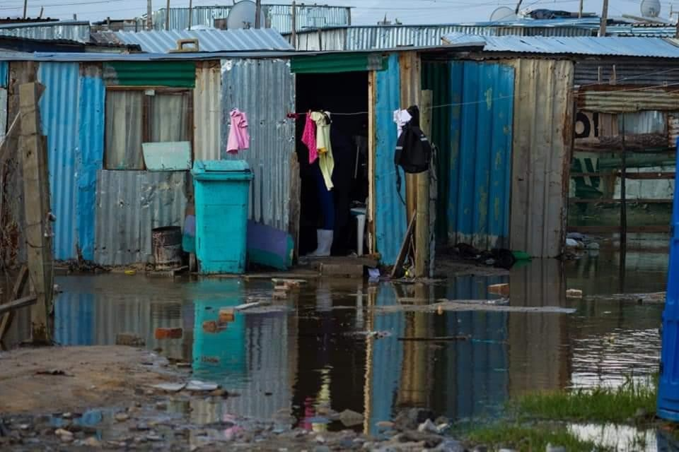

**FIG 3.3: INFORMAL SETTLEMENTS IN A FLOOD-PRONE AREA**

# IMPACT OF FLOODS

Floods have a wide-ranging impact on various aspects of society, economy, and the environment. Understanding these impacts is crucial for developing effective mitigation and response strategies.

### Social Impact Loss of Life and Injury:

Floods can result in significant loss of life and cause injuries to many people. The immediate effects of drowning, physical trauma, and exposure to hazardous conditions during floods contribute to high mortality and morbidity rates.

### Displacement and Homelessness:

Floods often force people to leave their homes, leading to temporary or permanent displacement. Evacuated individuals face challenges in finding shelter, food, and basic necessities, and prolonged displacement can have severe psychological and social consequences.

### Health Issues:

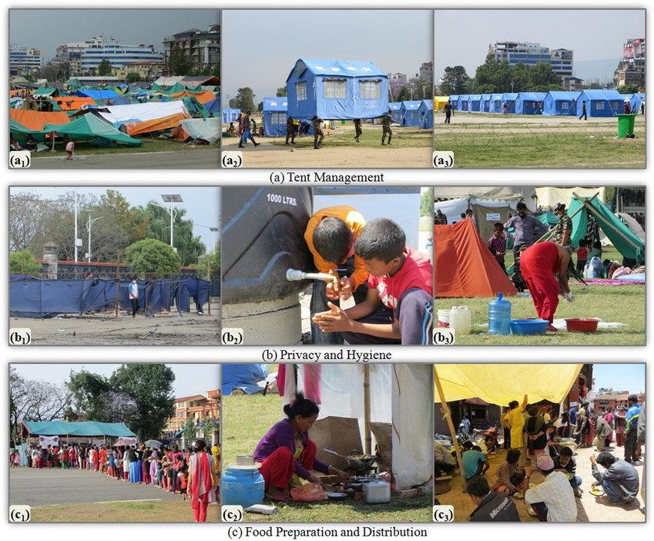Standing floodwaters can become breeding grounds for waterborne diseases such as cholera, dengue, and malaria. Lack of access to clean drinking water and sanitation facilities further exacerbates health risks for affected populations.

### Fig 3.4: Displaced families in temporary shelters after a flood

* + 1. **Environmental Impact Erosion and Sedimentation:**

Floods cause soil erosion and the deposition of sediment in riverbeds and floodplains. This can alter the landscape, affect agricultural productivity, and disrupt natural habitats.

### Water Quality Degradation:

Floodwaters often carry pollutants, chemicals, and debris, leading to contamination of water sources. This can affect drinking water supplies, harm aquatic ecosystems, and pose long-term environmental challenges.

### Loss of Biodiversity:

Floods can lead to the loss of flora and fauna in affected areas. The destruction of natural habitats and the displacement of wildlife disrupts ecosystems and can lead to a decline in biodiversity.

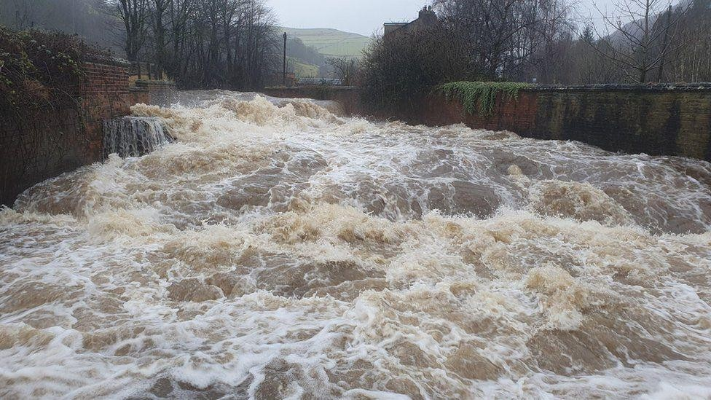

**Fig 3.5: ENVIRONMENTAL IMPACT OF FLOODS ON A RIVER ECOSYSTEM**

## FLOOD ECONOMY AND RESPONSES

The economic impact of floods extends beyond immediate damage, influencing long-term economic stability and growth. Effective responses to floods are crucial for mitigating these impacts and ensuring swift recovery.

### Economic Responses Government Relief Programs:

Governments often implement relief programs to support affected communities. These programs may include financial aid, subsidies for rebuilding, and provision of essential services.

### International Aid and Assistance:

In severe flood events, international organizations and countries may provide aid and assistance. This can include financial support, humanitarian aid, and technical expertise in disaster management.

### Insurance and Risk Management:

Developing comprehensive insurance schemes and risk management strategies can help mitigate the financial impact of floods. Encouraging individuals and businesses to adopt flood insurance can provide a safety net and support faster recovery.

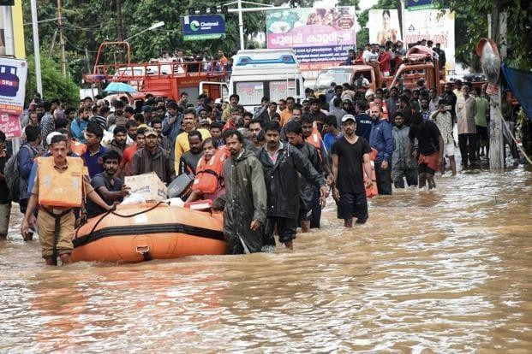

**Fig 3.6: GOVERNMENT RELIEF EFFORTS FOLLOWING A FLOOD**

## FLOOD RESPONSE FORCES

In the event of a flood, various specialized forces and agencies play a crucial role in rescue and relief operations. These forces include disaster response teams, military units, and volunteer organizations.

### Task Forces and Disaster Response Teams National Disaster Response Force (NDRF):

The NDRF is a specialized force in India tasked with disaster response and relief operations. They are equipped with trained personnel and advanced equipment to conduct rescue missions, provide medical aid, and support recovery efforts.

### State Disaster Response Forces (SDRF):

Each state in India has its own SDRF to respond to local disasters. These forces work in coordination with the NDRF and other agencies to ensure timely and effective response to flood situations.

### Local Emergency Services:

Local emergency services, including fire brigades, police, and medical teams, are often the first responders during floods. Their quick action and coordination are vital for saving lives and minimizing damage.

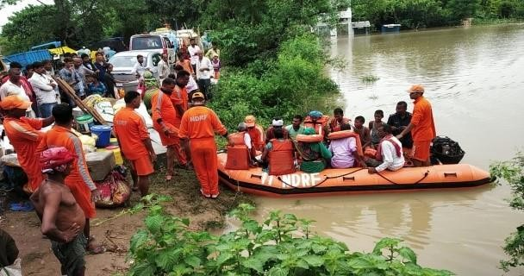

**Fig 3.7: NDRF TEAM CONDUCTING A RESCUE OPERATION DURING A FLOOD**

## MILITARY AND PARAMILITARY FORCES

### Indian Army:

The Indian Army plays a significant role in flood relief operations. They provide manpower, logistics support, and technical expertise in search and rescue missions, evacuation, and distribution of relief supplies.

### Indian Air Force:

The Indian Air Force is crucial in aerial surveys, airlifting stranded individuals, and delivering essential supplies to inaccessible areas. Helicopters and aircraft are used for quick response and efficient aid distribution.

### Indian Navy

The Indian Navy assists in flood relief operations, especially in coastal and riverine areas. They provide boats, divers, and medical assistance to support rescue missions and relief efforts.

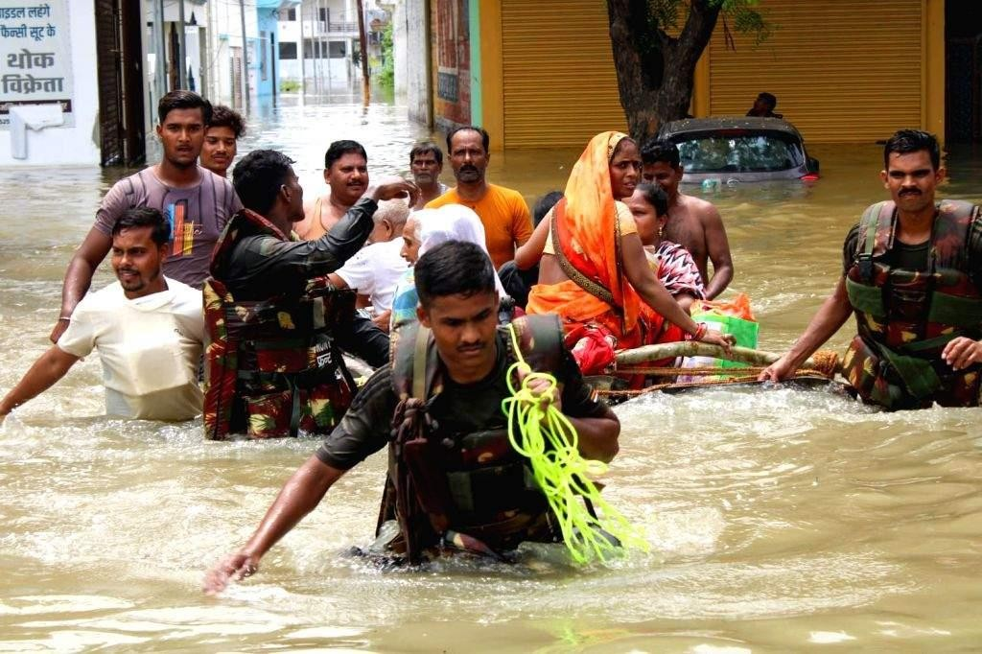

## FIG 3.8: INDIAN ARMY PERSONNEL ASSISTING IN FLOOD RELIEF OPERATIONS

### Conclusion

Addressing the challenges of flood management in Maharashtra requires a comprehensive approach that includes infrastructural improvements, administrative efficiency, financial investments, and community engagement. By implementing these remedies and fostering collaboration among various stakeholders, the state can significantly reduce the impact of floods and enhance resilience against future events.

# CHAPTER 4: FLOOD MANAGEMENT SYSTEM IN MAHARASHTRA

Flood is a makeshift deluge of abundant domains as the result of an increase in accumulation, or of waterways inundation their banks by way of difficult rains, extreme winds, windstorms, storm surge ahead coast, giant sea wave, softening snowstorm or dam bursts. Maharashtra is majorly accessible to floods. Also, floods are not just limited to individual particular domain, but are spread everywhere united states of America. Maharashtra, accordingly, exhibits an extreme bent to floods. Most floods happen all along cyclone and therefore, the following damage to a degree dying on account of electrical discharge, landslides, family crashes and immersing have happened usually stated from most precincts. Analyzing the floods in Maharashtra, individual observes that most floods in Maharashtra are flash floods on account of nallah-overflows and weak seepage systems.

## INFRASTRUCTURE DEVELOPMENT AND MAINTENANCE:

Infrastructure development and maintenance of flood management systems in Maharashtra involve a comprehensive approach to mitigate the impacts of flooding, which is a recurring natural disaster in the region. Here's a detailed report on the subject:

### Introduction

Maharashtra, a state in western India, faces annual challenges from floods due to its geographical location and monsoon rainfall patterns. To address these challenges effectively, the state government has implemented various infrastructure projects aimed at managing floods and minimizing their socio-economic impact.

### Infrastructure Development Initiatives

1. Flood Control Infrastructure:

Embankments and Dams: Maharashtra has constructed several embankments and dams across rivers prone to flooding. These structures help regulate water flow during heavy rains and prevent overflow into populated areas. Canals and Channels: Constructing canals and channels helps divert excess water away from urban centers and agricultural lands, reducing the risk of inundation.

1. Reservoirs and Water Storage: Large Reservoirs: Projects like the Koyna Dam and the Bhatsa Dam are crucial in storing excess water during the monsoon season. These reservoirs not only prevent floods downstream but also provide water for irrigation and drinking purposes during dry
2. Urban Drainage Systems: Stormwater Drains: Modern cities like Mumbai have developed extensive stormwater drainage systems to efficiently carry rainwater away from streets and residential areas. Regular maintenance of these drains is essential to ensure they function optimally during heavy rainfall events.
3. Flood Forecasting and Early Warning Systems: Weather Monitoring: Continuous monitoring of weather patterns and river levels allows authorities to anticipate potential flood situations.Early Warning Systems: Implementation of advanced technology for early warning systems ensures that residents in flood-prone areas receive timely alerts, enabling them to evacuate to safer locations.
4. 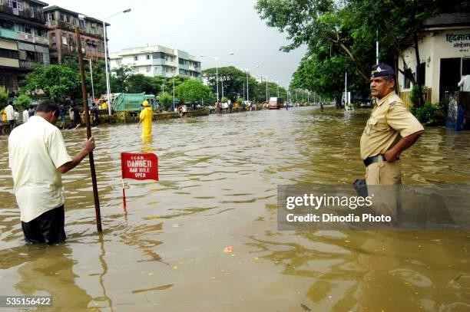

## FIG 4.1.MUMBAI POLICE STANDS GUARD FORCES INDIA

### Maintenance Strategies

1. **Regular Inspections and Repairs**: Structural Integrity Checks: Periodic inspections of dams, embankments, and canals are conducted to identify any signs of wear or potential failures.Repair and Rehabilitation: Immediate repairs are carried out to address any damages discovered during inspections, ensuring infrastructure remains robust and effective.
2. **Community Engagement and Awareness**: Training Programs: Educating local communities about flood preparedness and response strategies enhances their ability to cope with flood emergencies. Mock Drills: Conducting regular mock drills helps residents practice evacuation procedures and familiarize themselves with designated safe shelters.
3. **Collaboration with Research Institutions:** Research and Development: Collaborating with universities and research institutions facilitates the development of innovative flood management techniques and technologies. Data Analysis: Utilizing data analytics to predict flood patterns and optimize infrastructure maintenance schedules improves overall efficiency.

51

### Challenges and Future Directions

Despite these efforts, Maharashtra faces several challenges in its flood management endeavors: Climate Change: Increasingly erratic weather patterns necessitate adaptive strategies in flood management. Urbanization: Rapid urban growth puts pressure on existing drainage systems and increases vulnerability to flooding. Funding: Adequate financial resources are crucial for maintaining and upgrading flood control infrastructure.

### Future Directions:

Green Infrastructure: Implementing green solutions such as rain gardens and permeable pavements can mitigate urban flooding. Capacity Building: Enhancing the capacity of local governments and communities to manage floods independently. International Collaboration: Learning from global best practices and technological innovations in flood management.

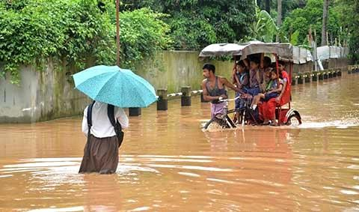

### Fig.4.2. STRUGGLE OF PEOPLE IN FLOOD

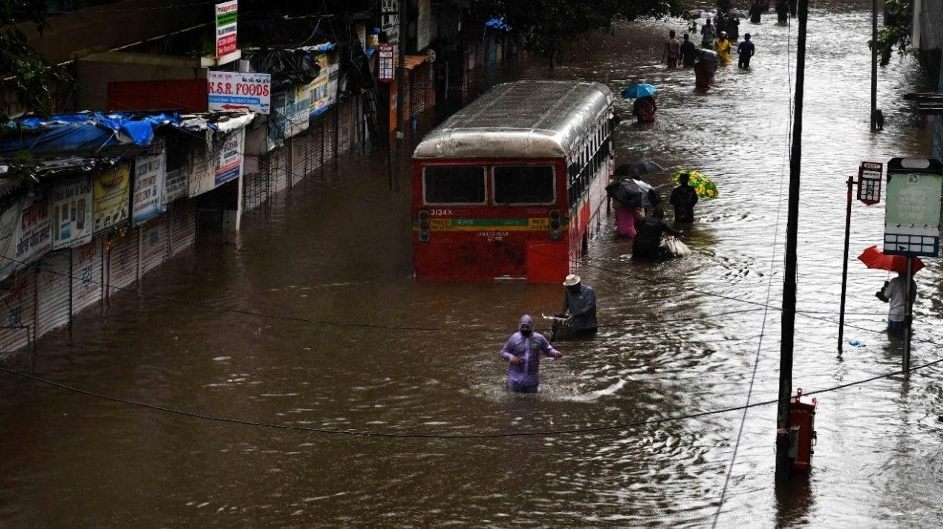

52

**Fig 4.3. FLOOD IN MUMBAI 2005**

## EARLY WARNING RECOVERY

### Community based flood forecasting and warning systems:

It is important that the people in each community receive information as early as possible about the possibility of flooding in their area. The way in which messages are disseminated in communities will depend on local conditions, but may include some or all of the following: Media warnings (print and electronic)General warning indicators, for example sirens, Warnings delivered to areas by community leaders or emergency services.Dedicated automatic telephone warnings to at-risk properties .Information about flooding and flood conditions in communities upstream. One approach to disseminating messages is to pass warning messages from village to village as the flood moves downstream. Keep watch and be regularly informed about the river level and embankment conditions in the local area. The monitoring of the river and embankment should be increased as the water level increases and crosses the critical danger level. A community-based warning system to pass any information about an approaching flood to every family.

### Involvement of communities in data collection and local flood warning systems :

If communities become involved in data collection for flood forecasting, and the importance of their role is understood, a sense of ownership is developed. Individuals can be appointed for the following tasks: Taking care of installations/ equipments, Trained as gauge readers for manual instruments (rain gauges, water level recorders), Radio operators to report real-time observations. Trained individuals within the community should be able to gather and update information to: Know the depth of past severe floods in the local area, Know the causes of flooding in the local area, Know how quickly the waters might rise, Know how long the floodwaters might remain in the locality, Know the direction of movement of the floodwaters, The involvement of members of the community also helps to prevent vandalism and damage to installations going unreported.

### Procedure for disseminating warnings to remote areas

Communities in remote areas may not be able to receive the types of warnings described in the previous section. Responsibilities need to be defined clearly for lower tiers of administration and the emergency services to have predefined links with communities in remote areas. This should include: Local radio, which should be supplied with clear and accurate information. Use of appointed community wardens with direct two-way radio or mobile telephone access to warning agencies and emergency authorities. Local means of raising alarms, for example church bells, sirens, loud hailers, loudspeakers etc.

### Trigger Mechanism: Plan Activation

The flood response system will be activated on the occurrence of a heavy rain. The Secretary of R & R will activate all the Departments for emergency response including the State EOC, other control rooms at the state level as well as district control rooms with full strength. He will issue instructions to include the following details: Specify exact resources required , The type of assistance to be provided, The time limit within which assistance is needed, The state, district or other contact persons/agencies for the provision of the assistance.Other Task Forces with which coordination should take place.Once the situation is totally controlled and normalcy is restored, the Secretary R & R declares End of Emergency Response and issues instructions to withdraw the staff deployed in emergency duties.

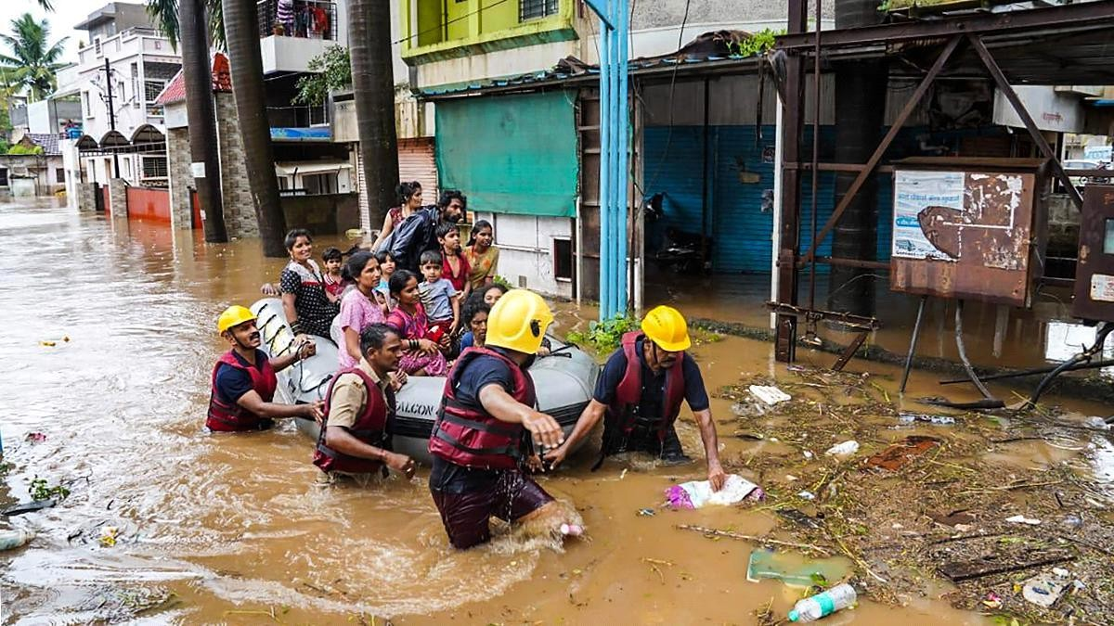

### Fig 4.4.RESCUE OPERATION TO SAVE PEOPLE LIVES

* + 1. **Objectives**

The primary objective of the EWS is to reduce the loss of life and property by providing early and accurate warnings of impending floods. Specific goals include: Timely Alert System: To provide timely warnings to communities at risk, enabling them to take appropriate preparedness actions, Risk Assessment and Monitoring: Continuous monitoring of weather patterns, river levels, and other relevant indicators to assess flood risk. Capacity Building: Enhance the capacity of local authorities and communities to interpret warnings and respond effectively. Integration with Response Mechanisms: Seamless integration with disaster response mechanisms to facilitate swift action.

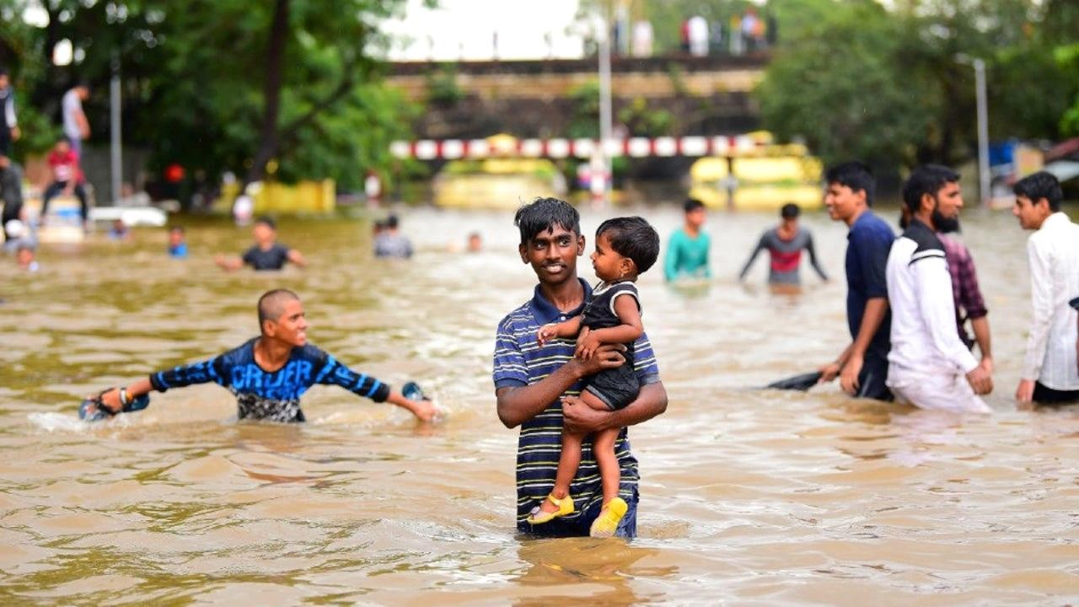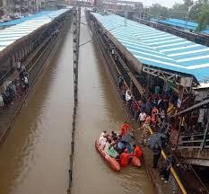

### Fig 4.5MUMBAI LOCAL TRAIN DURING FLOODS

* 1. **Policy Framework for Flood Management in Maharashtra**

Floods pose a significant threat to Maharashtra, impacting lives, infrastructure, and the economy. A comprehensive policy framework is essential to mitigate these risks effectively and enhance resilience. This framework outlines strategic objectives, key components, and implementation strategies to achieve sustainable flood management in the state.

* + 1. **Objectives:** Risk Reduction: Reduce the vulnerability of communities and infrastructure to flood hazards through proactive measures. Integrated Approach: Adopt an integrated approach that combines structural and non-structural measures for effective flood risk management. Community Resilience: Build community resilience by promoting awareness, preparedness, and participation in flood management efforts.

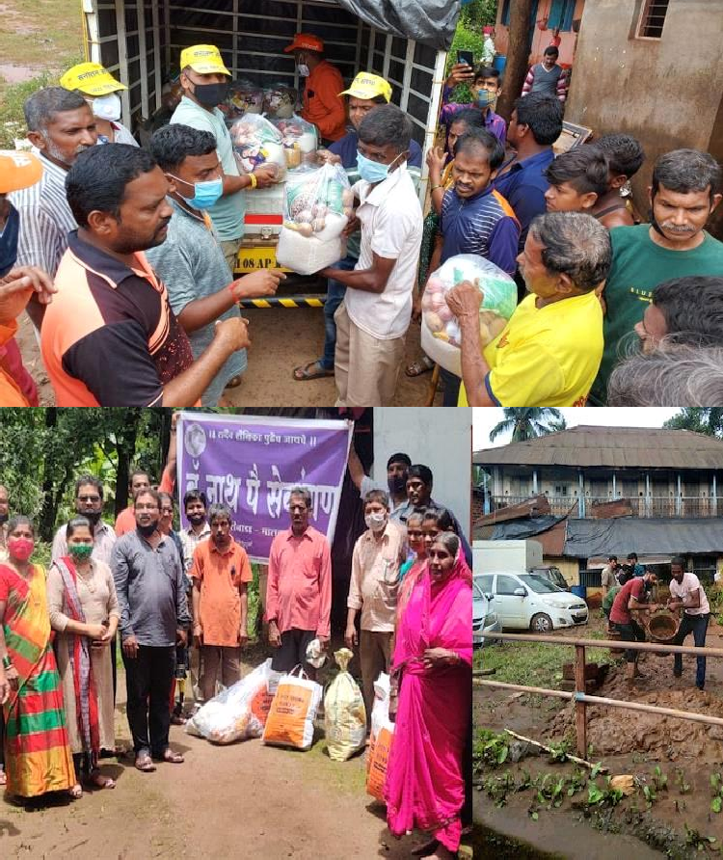

### Fig 4.6. CHIPLUN PEOPLE SAVED LIVES DURING FLOOD

* + 1. **Policy Components**

1. Legal and Institutional Framework:

Legislation: Enact or revise legislation to support comprehensive flood management, disaster risk reduction, and climate change adaptation. Institutional Setup: Define clear roles and responsibilities for state and local government agencies, disaster management authorities, and relevant departments. Coordination Mechanisms: Establish effective coordination mechanisms among stakeholders to ensure a unified approach to flood management.

1. **Risk Assessment and Mapping**: Flood Hazard Mapping: Develop and update flood hazard maps using advanced technology and data analysis to identify high-risk areas.
2. **Early Warning Systems (EWS):** Enhancement: Strengthen and integrate EWS that utilize meteorological and hydrological data to provide timely alerts to communities and authorities. Community Engagement: Promote community participation in EWS through education, training, and local communication channels.
3. **Infrastructure Development and Maintenance**: Structural Measures: Invest in the construction, maintenance, and retrofitting of flood control infrastructure such as embankments, reservoirs. Nature-Based Solutions: Encourage nature-based solutions like wetland enhance flood resilience and water management
4. **Capacity Building and Awareness**: Training Programs: Conduct regular training for government officials, emergency responders, and community leaders on flood preparedness, response, and recovery. Public Awareness Campaigns: Launch campaigns to educate citizens about flood risks, safety measures, and the importance of early warning systems.
5. **Research and Innovation**: Research Support: Allocate resources for research on climate change impacts, innovative flood management techniques, and technology-driven solutions. Pilot Projects: Support pilot initiatives to test and scale innovative flood management strategies suited to Maharashtra's geographic and climatic conditions.
6. **Financial Mechanisms**: Budget Allocation: Ensure sufficient funding for flood management activities, including infrastructure development, maintenance, and emergency response. Insurance and Risk Transfer: Promote insurance schemes and risk transfer mechanisms to provide financial protection against flood-related losses.
7. **Monitoring and Evaluation**: Performance Metrics: Develop measurable indicators to assess the effectiveness of flood management policies and interventions. Feedback Mechanisms: Establish mechanisms for stakeholder feedback and periodic reviews to improve policy implementation and response capabilities.
8. **International Collaboration**: Knowledge Sharing: Engage in international partnerships to exchange best practices, technologies, and expertise in flood management and disaster risk reduction. A robust policy framework for flood management in Maharashtra should prioritize risk reduction, integrate diverse strategies, empower communities, and ensure sustainable development. By implementing these measures, Maharashtra can enhance its resilience to floods and safeguard the well-being of its citizens and environment for generations to come.

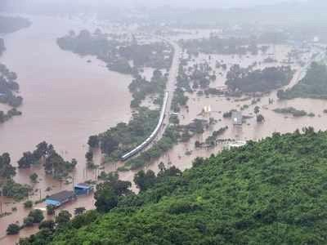

**Fig 4.7. MAHARASHTRA DROWNED IN FLOOD**

**Conclusion:**

To wrap up, Maharashtra's flood management system shows both strong points and areas that need work. The state's forward-thinking approach has a big impact on managing and reducing flood risks. It does this by bringing in advanced forecasting tech making infrastructure better, and helping people understand more. But there are still problems to solve. These include making infrastructure stronger sharing data faster, and using local know-how in management plans.To make the flood management system even better, it's crucial to keep putting money into strong infrastructure upgrades.. Also, it's important to start using new tech for early warnings and real-time tracking. This will help make flood predictions more accurate and timely. Getting the community involved and preparing at the local level should also be a key focus, as it can make flood risk management more effective and long-lasting when residents play a part. Getting locals to take part and using their traditional know-how can work well with modern methods to build a stronger system for dealing with floods. To wrap up even though we've come a long way, we need a full and flexible approach that tackles both current and new issues. This will be key to keep Maharashtra's communities safe and able to bounce back from future floods. Working together over time is crucial for managing floods

# CHAPTER 5: GOVERNMENT POLICIES

In Maharashtra, as in many other regions prone to natural disasters, the government has implemented a variety of policies to address and mitigate the impact of floods. Here's an introduction to the key policies and measures that are typically involved:

### Disaster Management Framework

The Government of Maharashtra follows a structured approach to disaster management, which includes:

**National Disaster Management Act, 2005:** This Act provides the overarching framework for disaster management in India, including flood management. It establishes the National Disaster Management Authority (NDMA), which sets policies, plans, and guidelines for disaster management. It received the assent of The [President of India](https://en.wikipedia.org/wiki/President_of_India) on 23 December 2005. The Disaster Management [Act](https://en.wikipedia.org/wiki/Act_of_Parliament), 2005 has 11 chapters and 79 sections. The Act extends to the whole of India. The Act provides effective management of disasters and for matters connected there with or incidental "thereto".

**State Disaster Management Authority (SDMA):** Maharashtra has its own State Disaster Management Authority which formulates and implements policies related to disaster management at the state level. The State Disaster Management Authority was established in the State under the Chairmanship of the Chief Minister with 8 other members under section 14 of the Disaster Management Act,2005 by a Government notification dated 26th June, 2008. It is the apex body for disaster management in the State.

### Flood Management Plans

Maharashtra has developed comprehensive flood management plans that include:

**Flood Control Infrastructure:** This involves the construction and maintenance of embankments, floodwalls, and dams to control and manage water flow and mitigate flood impacts. Methods of Control. In many countries, rivers prone to floods are often carefully managed. Defenses such as levees, bunds, reservoirs, and weirs are used to prevent rivers from bursting their banks. When these defenses fail, emergency measures such as sandbags or portable inflatable tubes are used.

**Flood Forecasting and Early Warning Systems:** The state uses meteorological data and river flow monitoring to predict floods and issue early warnings to affected communities. A flood warning system is a way of detecting threatening events in advance. This enables the public to be warned en masse so that actions can be taken to reduce the adverse effects of the event.

**Drainage Improvement Projects**: Improving urban and rural drainage systems ensure to efficient water removal and reduce flood risk. PUB has an island-wide drainage improvement programme to continually upgrade our drainage infrastructure to cater for new developments, alleviate flood risk and rehabilitate aging infrastructure. These “pathway” improvements include widening and deepening our drains and canals, constructing diversion canals and catchment level detention systems.

**Emergency Response and Relief:** The state government has established protocols for emergency response and relief, including: state Disaster Response Force (SDRF): A specialized force trained for disaster response, including flood situations, that operates under the direction of the State Disaster Management Authority. Relief Measures: Provision of immediate relief such as food, medical aid, and temporary shelter for affected populations. The government also provides financial assistance and support for the rehabilitation of flood-affected communities.

**Community Involvement and Awareness:** Efforts to involve local communities and increase awareness include: Community-Based Disaster Management take Initiatives to involve local communities in disaster preparedness and response activities, including training and capacity building. Public Awareness Campaigns: Educational programs to inform citizens about flood risks, preparedness measures, and safety protocols.

**Resilience Building and Long-Term Strategies:** To build long-term resilience against floods, the state government focuses on: Urban Planning and Land Use Regulations: Implementing and enforcing regulations to prevent construction in flood-prone areas and promoting sustainable land use practices. Environmental Conservation: Protecting natural buffers such as wetlands and forests that help absorb excess water and reduce flood risks.

## 5.3 ADMINISTRATIVE STRUCTURE :-

The administrative structure for managing natural disasters, particularly floods, in Maharashtra is a comprehensive system involving multiple levels of government and various agencies. Here’s a detailed overview:

### Central Government

Ministry of Home Affairs (MHA):National Disaster Management Authority (NDMA): Formulates policies, plans, and guidelines for disaster management.National Disaster Response Force (NDRF): Provides specialized response and rescue operations during disasters.Ministry of Earth Sciences (MoES):Provides meteorological forecasts and flood warnings through the India Meteorological Department (IMD).

### State Government

State Disaster Management Authority (SDMA) Maharashtra State Disaster Management Authority (MSDMA): Oversees disaster management at the state level, formulates policies, and coordinates with various departments.Revenue Department:State Relief Commissioner Coordinates relief efforts and manages funds during and after a disaster.District Collectors Act as the primary point of contact for disaster management in each district.

### District Administration

District Disaster Management Committees: District Collector: Leads the disaster management efforts at the district level, including coordination of rescue operations, relief distribution, and damage assessment.

Taluka and Village-Level Committees: Taluka Development Officers: Oversee disaster management activities at the taluka level. Village Heads (Sarpanch**)**: Play a crucial role in community-level disaster preparedness and response.

### Local Authorities

Municipal Corporations and Councils: Handle urban disaster management, including infrastructure, evacuation, and emergency services. Public Works Department (PWD) Responsible for maintaining and managing flood control infrastructure, such as dams, embankments, and drainage systems.

### Coordination and Communication

Non-Governmental Organizations (NGOs) and Community-Based Organizations (CBOs)Local NGOs: Assist in relief and rehabilitation efforts, community awareness, and preparedness activities.CBOs: Engage in grassroots-level disaster management, including awareness programs and volunteer support.

### Disaster Preparedness and Mitigation

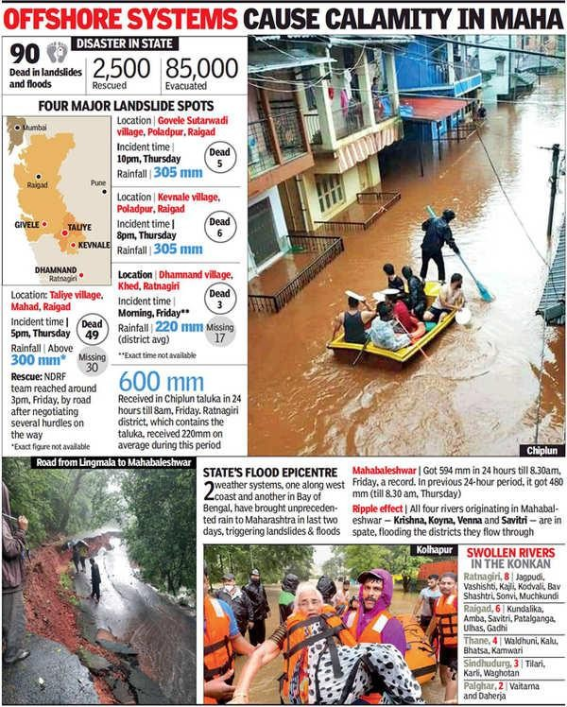Disaster Management Plans:Developed by both the central and state governments, these plans outline procedures for preparedness, response, and recovery specific to floods and other natural disasters.Training and Capacity Building Ongoing training programs for government officials, emergency responders, and community members to enhance preparedness and response capabilities.This multi-tiered structure ensures that disaster management efforts are well- coordinated, effective, and responsive to the needs of the affected communities.

## LEGISLATIVE & GOVERNANCE:-

In Maharashtra, the legislative and governance frameworks for managing natural disasters, such as floods, are designed to create a structured approach for disaster preparedness, response, and recovery. Here’s an overview of the relevant legislative and governance aspects:

Legislative framework

Disaster Management Act, 2005 : National Disaster Management Act, 2005: This act provides the framework for disaster management in India and establishes the National Disaster Management Authority (NDMA), the State Disaster Management Authority (SDMA), and the District Disaster Management Authority (DDMA).Maharashtra State Disaster Management Act: Maharashtra has aligned its legislation with the national framework, creating the Maharashtra State Disaster Management Authority (MSDMA) to oversee disaster management at the state level.

The Indian Penal Code (IPC) and The Criminal Procedure Code IPC and CrPC: Provide the legal basis for addressing issues such as negligence and criminal liability related to disaster management and response.

Environment Protection Act, 1986: Environment Protection Act: Includes provisions for managing environmental issues that can exacerbate the impact of natural disasters, such as floods.

Water Resources Act: Maharashtra Water Resources Regulatory Authority (MWRRA): Regulates water resources in the state, including flood control measures and management of river systems.

## E-GOVERNANCE INITIATIVES:-

E-Governance initiatives in the context of natural disaster management, particularly floods, are crucial for enhancing the effectiveness, efficiency, and transparency of disaster response and management processes. In Maharashtra, several e-Governance initiatives have been implemented to streamline disaster management and improve flood response. Here’s an overview:

Integrated Disaster Management System (IDMS)

A comprehensive platform developed for disaster management, integrating various tools and databases to facilitate efficient disaster response and management.Features are Real- time data collection, management, and dissemination related to disasters, including floods.

63

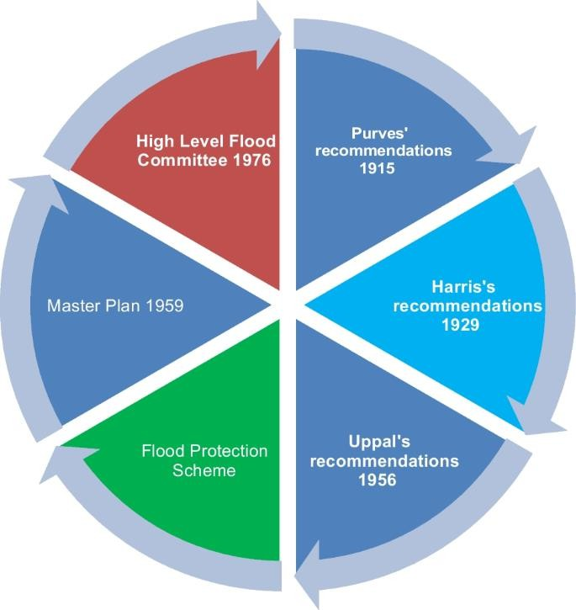

**Fig 5.2. GOVT DRAFTS REHAB POLICY**

**Flood Forecasting and Early Warning Systems**

Maharashtra State Remote Sensing Application Centre (MRSAC).Provides remote sensing and GIS-based flood monitoring and forecasting services.Functios to Utilizes satellite imagery and data for real-time monitoring and early warning.India Meteorological Department (IMD) Integration Collaborates with IMD for weather forecasting and flood warnings. featueres are Disseminates weather forecasts, flood alerts, and advisories through digital platforms.

Emergency Response and Management Platforms

State Emergency Operations Centre (SEOC) Acts as the central hub for disaster management coordination at the state level. Utilizes GIS, communication systems, and data analytics to manage emergency responses effectively.District Emergency Operations Centres (DEOCs) Operates at the district level to manage local disaster responses .Links with SEOC and other state-level agencies for a coordinated response.

### Public Information and Awareness

Maharashtra Disaster Management Portal A dedicated online portal providing information on disaster management, preparedness, and response Includes real-time flood information, safety guidelines, and updates on ongoing disaster situations.Mobile Apps .Flood Monitoring Apps: Developed for public use to provide real-time flood alerts, safety tips, and emergency contact information.Community Engagement Allows citizens to report flood incidents and access vital information.

Data Management and Analysis

State Disaster Management Database a centralized database for managing disaster-related information, including flood data, damage assessments, and relief distribution.Facilitates data sharing and analysis for better decision-making.

Coordination and Collaboration Platforms

E-Governance Platforms : Maharashtra State Government Portal: Provides a platform for inter-departmental communication and coordination regarding disaster management.Inter-agency Communication: Facilitates seamless information exchange between various government departments, NGOs, and other stakeholders.Collaboration: Engages private sector companies in developing and maintaining e-Governance tools and platforms for disaster management. Encourages the development of new technologies and solutions for flood management and response.

Training and Capacity Building

Online Training Programs Offers online courses and training modules for government officials, emergency responders, and the general public Includes disaster preparedness, response strategies, and the use of e-Governance tools Simulation and Drills . Conducts online simulations and exercises to prepare stakeholders for flood scenarios and test the efficacy of e-Governance tools.

Feedback and Evaluation

Evaluation Systems utilizes e-Governance tools to monitor and evaluate disaster response efforts and outcomes.Feedback Mechanisms: Collects feedback from affected communities and stakeholders to improve disaster management practices.Reports and Analytics Generates reports and analytics on flood events, response efficiency, and areas for improvement.

These e-Governance initiatives enhance the ability of Maharashtra’s disaster management system to respond to floods effectively, ensuring better preparedness, quicker response times, and improved coordination among stakeholders

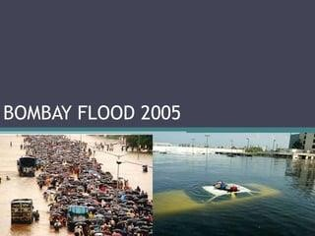

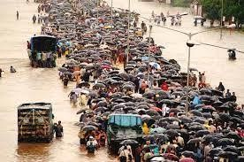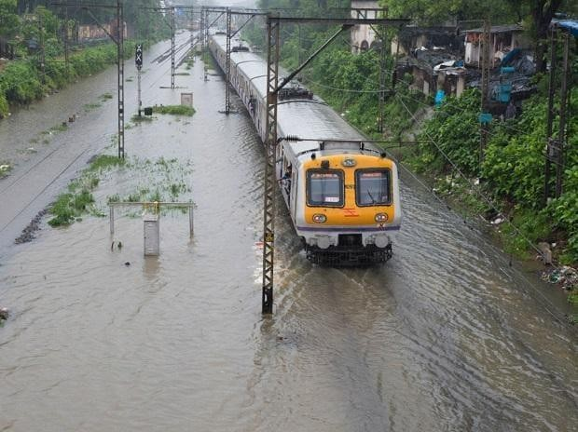

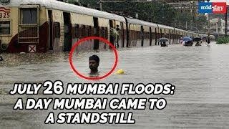

## FIG.5.3.26 JULY 2005: 13 YEARS SINCE MUMBAI WAS FLOODED LIKE NEVER BEFORE

* **CONCLUSION:** Government policies on natural disasters, particularly floods, are vital for protecting people and reducing damage. In Maharashtra, these policies focus on early warning, better urban planning, disaster preparedness, and effective relief and rehabilitation. While these measures have helped, continuous improvement and adaptation are needed to deal with the growing challenges of climate change and urbanization. By strengthening these policies, the government can better safeguard communities and ensure quicker recovery from floods.

**CHAPTER 6: CASE STUDY**

* 1. **ARTICLES-**

**ARTICLE 1**

Navi Mumbai: A stretch of the Mumbai-Pune highway remains flooded for over a week as the covered storm water drain has been choked in Khopoli. The Maharashtra State Road Development Corporation did not clean the drain ahead of monsoon resulting in traffic congestion. Some vehicle drivers dare to wade through the water. However, activists allege that neither the corporation nor the Khopoli municipal council attends to the problem.

The corporation has served a notice to a builder asking them to clean up the drain. The Mumbai- bound carriageway of the highway is regularly flooded for about 1km on this stretch. The vehicles start moving on the Pune-bound carriageway causing traffic snarls. Heavy rains led to flooding of both the carriageways. Many vehicles have broken down, adding to motorists’ woes. Locals say the highway stretch has not been constructed by properly maintaining the required height or elevation.

-Umesh K Parida

## ARTICLE 2

Mumbai is facing heavy rains and severe waterlogging, and the India Meteorological Department (IMD) has issued a ‘red’ alert for several parts of Maharashtra till July 24.

The city and its surrounding areas, including the suburbs and nearby districts of Thane, Palghar, and Raigad, are preparing for more intense rainfall. A high tide alert has been issued for Tuesday afternoon. The IMD has predicted heavy rain for Mumbai and Thane, issuing a 'yellow' alert for Tuesday and an 'orange' alert for Wednesday.

A ‘red’ alert, signalling the highest level of caution, has been extended to Gujarat, Konkan, Goa, and West Madhya Pradesh, underscoring the seriousness of the weather situation.

Since Saturday evening, relentless heavy rain has led to widespread waterlogging and significant traffic disruptions. In Bhandup, a mobile tower collapsed, damaging several houses but no casualty was reported.

### Maharashtra rains: NDRF teams deployed

With a heavy rainfall warning in effect, the National Disaster Response Force (NDRF) has mobilised teams throughout Maharashtra. Apart from their usual presence in Mumbai and Nagpur, NDRF units are now positioned in Vasai (Palghar), Thane, Ghatkopar, Powai (Kurla), Mahad (Raigad), Khed and Chiplun (Ratnagiri), Kudal (Sindhudurg), Kolhapur, Sangli, and Satara.

### IMD weather update: Heavy rains across India

The IMD forecasts widespread light to moderate rainfall, accompanied by thunderstorms and lightning, across West, Central, East, and South Peninsular India over the next five days.

## ARTICLE 3

Pune Rain News

Like Mumbai, Pune also faces a red alert till Friday morning.

The Army has been called in to help disaster response teams, with authorities reporting severe flooding in areas like Ekta Nagri and Vitthal Nagar and in housing societies in Kalyaninagar.

The city has also experienced widespread power outages; officials told The Times of India in 90 per cent of these cases supply had been switched off to avoid water-related electrical mishaps. Schools and colleges in the city were ordered to close for the day.

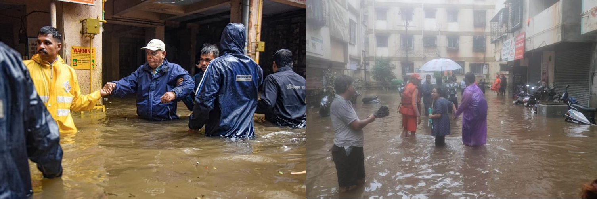

**Fig 6.1.RED ALERT AREAS IN PUNE**

## ARTICLE 4

Pune Mumbai Rain Live News: Mumbai and Pune face rain red alerts till 8.30 am Friday. Mumbai: Four people have died - three were electrocuted - in Pune, two drowned after falling into Thane's Barvi Dam, and a red alert has been declared for Mumbai and Palghar after heavy rainfall, overnight and this morning, battered the three cities and other parts of Maharashtra Thursday.

The observatory in Mumbai's Santacruz has recorded over 1,500 mm of rain so far this month, making it the second wettest July in the city's history. The city groaned under 1,771 mm last July. The city 122.1 mm (between Santacruz and Colaba) between 8.30 am and 5.30 pm today.

The weather department has declared a red alert for Mumbai till 8.30 am Friday.

Four rivers in the state, including the Kundalika and Amba, are flowing above the danger mark and threaten to destroy villages and settlements along their banks. In addition, the Mithi River, which is adjacent to Mumbai's Chhatrapati Shivaji Airport, flowing just a metre below that mark. Flight ops at the airport have been affected by the rain; IndiGo and SpiceJet warned passengers of "periodic delays in flight schedules, and Air India offered full refunds for cancelled flights.

## ARTICLE 5

Pune: Shivajinagar in Pune city received 114 mm of rainfall in 24 hours ending at 8.30 am on Thursday, the third-highest in a single day in 66 years, according to India Meteorological Department.

At 130.4 mm, the highest 24-hour July rainfall in Shivajinagar in central Pune was recorded on July 19, 1958, followed by 117.9 mm on July 27, 1967, they said.

Citing data from the Shivajinagar weather station, officials said the area received 114 mm of rain between 8.30 am on Wednesday and 8.30 am on Thursday

Heavy rains since Wednesday evening have wreaked havoc in Pune, where at least four persons died in rain-related incidents on Thursday, while several houses and residential societies in low- lying areas in the city were inundated, prompting evacuation, as per officials.

According to the IMD, the rainfall in the Lavasa area in Mulshi tehsil of Pune district stood at

455.5 mm in 24 hours (between 8.30 am on Wednesday and 8.30 am on Thursday), followed by Lonavala (322 mm), Nimgiri (232 mm), Malin (180 mm), Chinchwad (175 mm), Talegaon (167 mm), NDA (167 mm), and Lavale (166 mm).

Across Pune city, areas like Wadgaonsheri, Pashan, Shivajinagar and Hadapsar received rainfall between 108 mm and 140 mm in the 24 hours, said IMD officials.

Anupam Kashyapi, a former head at IMD Pune's weather forecasting department, termed the rains "record-breaking".

IMD has predicted "incessant heavy to very heavy rains" in Pune and its neighbouring areas and has forecast "red alert" (very heavy to extremely heavy) at isolated places in the ghat sections.

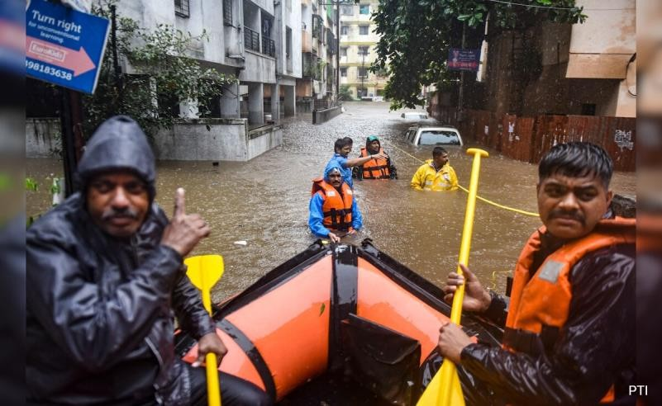

**Fig 6.2.: SHIVAJINAGAR IN PUNE**

**6.2 NEWS**

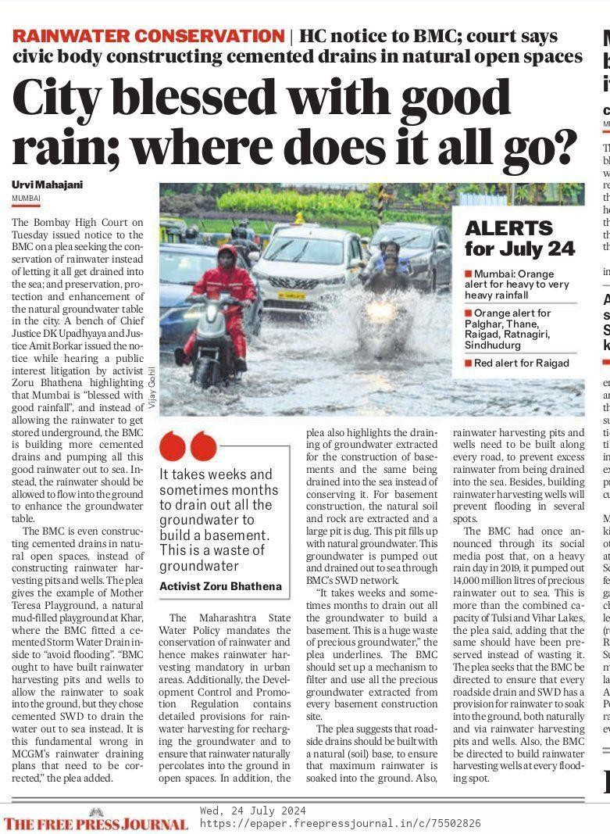

**Fig 6.3. NEWS ON BOMBAY HIGH COURT’S NOTICE**

The composition addresses the Bombay High Court’s notice to the BMC regarding rainwater conservation in Mumbai. Activist Zoru Bhathena’s public interest action points out that despite Mumbai’s ample downfall, the BMC is draining rainwater into the ocean using cemented rainspouts, rather than allowing it to replenish the groundwater. The plea emphasizes that constructing cemented rainspouts in natural open spaces wastes precious rainwater that could be conserved through harvesting recesses and wells. The Maharashtra State Water Policy authorizations rainwater conservation, but current practices by the BMC are seen as ineffective. The composition also highlights the waste of groundwater during basement construction and suggests enforcing natural filtration systems in roadside rainspouts and erecting rainwater harvesting structures to help flooding and conserve water.

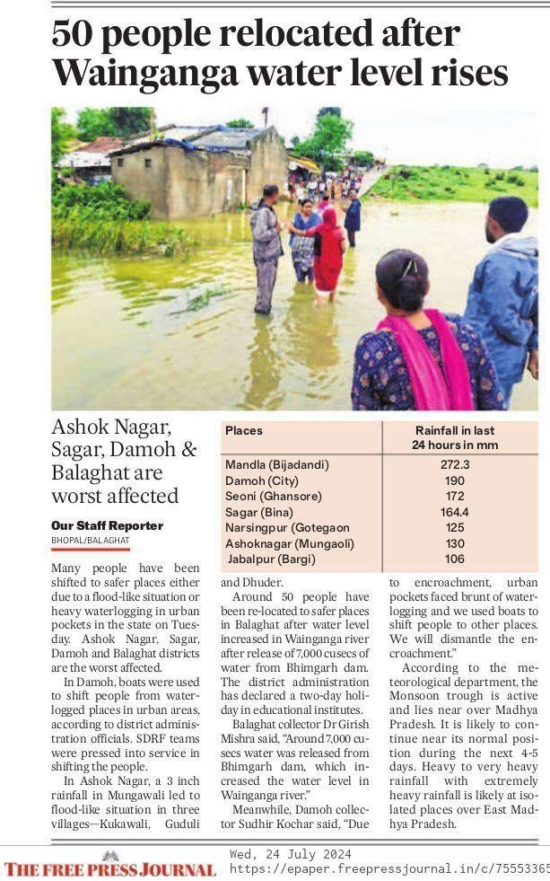

**Fig 6.4.NEWS ON FLOOD AFFECTED AREAS IN BALAGHAT**

Rainfall cautions for heavy downfall are issued for Mumbai and conterminous regions. Due to heavy downfall leading waterlogging, 50 people in Balaghat were dislocated after the Wainganga swash’s water position rose significantly. Ashok Nagar, Sagar, Damoh, and Balaghat sections are the worst affected areas. In Damoh, boats were used for evacuation, and SDRF brigades were involved in the operations. The meteorological department has read more heavy downfall in the coming days, which could complicate the situation.

## INTERVIEW QUESTIONS -

### Questions to ask a flood victim:-

1. This time the flood tide were terrible, weren’t they? Can you tell me further about it?
2. How did you manage to survive?
3. Did you suffer any particular loses?
4. Were there any relief measures?
5. Did any communal officers or political leaders come to visit you?
6. Have you been handed temporary accommodation?
7. You suppose your suffering could have been lower if some preventative measures had been taken?
8. Was any warning given?
9. Are there programs that will help you build your home?
10. One last question do you have any suggestions as to how similar flood tide can be averted?

### Questions to ask a government authority:-

1. What measures has the government put in place to prepare for and respond to floods in Maharashtra?
2. How effective are the early warning systems in place for predicting and alerting residents about potential floods?
3. Can you describe the evacuation plans and protocols in place for residents in flood-prone areas?
4. What steps are being taken to improve the resilience of critical infrastructure such as roads, bridges, and drainage systems to withstand floods?
5. How does the government ensure timely relief and recovery for flood-affected individuals and communities?
6. How are local communities involved in flood preparedness and response efforts?
7. What impact have recent floods had on agriculture in Maharashtra, and what measures are being taken to support affected farmers?
8. How is the government addressing the impact of climate change on the frequency and severity of floods in the region?
9. How resources are allocated for flood management and mitigation, and are there any recent changes in budget or policy?
10. How does the government coordinate with other agencies, both local and national, to manage flood situations effectively?









**GLOSSARY**

1. Embankments: Raised structures built along riverbanks or floodplains to prevent water from overflowing into surrounding areas.
2. Dams: Large barriers constructed across rivers or streams to control water flow, store water, and reduce flood risks.
3. Canals and Channels: Man-made waterways designed to divert excess water from flood- prone areas to prevent inundation.
4. Reservoirs: Large natural or artificial lakes used to store water, which helps manage water supply and mitigate flood risks.
5. Storm water Drains: Systems of pipes and channels that collect and direct rainwater away from urban areas to prevent flooding.
6. Flood Forecasting: The process of predicting potential flood events using meteorological and hydrological data.
7. Early Warning Systems (EWS): Technologies and procedures that provide advance alerts about potential floods to help communities prepare and respond.
8. Hydrological Data: Information related to the distribution and movement of water in the environment, including river levels and flow rates.
9. Meteorological Data: Weather-related information used to predict rainfall and potential flooding events.
10. Vulnerability Assessment: The process of evaluating the susceptibility of communities and infrastructure to flood hazards.
11. Green Infrastructure: Environmental solutions, such as rain gardens and permeable pavements that enhance natural water management and reduce flood risk.
12. Capacity Building: Efforts to improve the skills, knowledge, and abilities of individuals and organizations to manage flood risks effectively.
13. Risk Assessment: The evaluation of potential flood hazards and their impacts on communities and infrastructure.
14. Nature-Based Solutions: Strategies that utilize natural processes and ecosystems, such as

wetland restoration, to manage flood risks and enhance resilience.

1. State Emergency Operation Centre (SEOC): The primary facility responsible for coordinating flood response and emergency management at the state level.
2. Flood Control Infrastructure: Physical structures and systems designed to prevent or mitigate flood damage, including embankments, dams, and drainage systems.
3. Disaster Management Authority: Government bodies responsible for formulating and implementing policies related to disaster preparedness and response.
4. Community-Based Disaster Management: Localized efforts to involve residents in disaster preparedness, response, and recovery activities.
5. Public Awareness Campaigns: Educational programs aimed at informing the public about flood risks, safety measures, and preparedness actions.
6. Resilience Building: Activities and strategies focused on enhancing the ability of communities and infrastructure to withstand and recover from flood events.

**\**

**GLOSSARY INDEX**

|  |  |  |
| --- | --- | --- |
| **SR.NO** | **WORD** | **PAGE NO** |
| 1 | Embankments | 5 |
| 2 | Dams | 5 |
| 3 | Canals and Channels | 50 |
| 4 | Reservoirs | 36 |
| 5 | Stormwater Drains | 20 |
| 6 | Flood Forecasting | 37 |
| 7 | Early Warning Systems (EWS) | 57 |
| 8 | Hydrological Data | 57 |
| 9 | Meteorological Data | 59 |
| 10 | Vulnerability Assessment | 56 |
| 11 | Green Infrastructure | 52 |
| 12 | Capacity Building | 52 |
| 13 | Risk Assessment | 10 |
| 14 | Nature-Based Solutions | 57 |
| 15 | State Emergency Operation Centre (SEOC) | 64 |
| 16 | Flood Control Infrastructure | 50 |
| 17 | Disaster Management Authority | 59 |
| 18 | Community-Based Disaster Management | 60 |
| 19 | Public Awareness Campaigns | 37 |
| 20 | Resilience Building | 60 |

**BIBLIOGRAPHY**

**WEB REFERENCES-**

1. National Disaster Management Authority (NDMA)**. (2005). _National Disaster Management Act, 2005_. Government of India. Available at: [[http://ndma.gov.in](http://ndma.gov.in/)]([http://ndma.gov.in)](http://ndma.gov.in/)
2. Government of Maharashtra**. (2008). _State Disaster Management Authority (SDMA) Notification_. Maharashtra State Government. Available at: [[http://maharashtra.gov.in](http://maharashtra.gov.in/)]([http://maharashtra.gov.in)](http://maharashtra.gov.in/)
3. Central Water Commission (CWC)**. (n.d.). _Flood Management_. Available at: [[http://cwc.gov.in](http://cwc.gov.in/)]([http://cwc.gov.in)](http://cwc.gov.in/)
4. Indian Meteorological Department (IMD)**. (n.d.). _Weather Forecasting and Early Warning Systems_. Available at: [[http://imd.gov.in]](http://imd.gov.in/)([http://imd.gov.in)](http://imd.gov.in/)
5. Maharashtra State Irrigation Department**. (n.d.). _Flood Management Projects and Initiatives_. Available at: [[http://irrigation.maharashtra.gov.in]](http://irrigation.maharashtra.gov.in/)([http://irrigation.maharashtra.gov.in)](http://irrigation.maharashtra.gov.in/)
6. Public Works Department (PWD)**. (n.d.). _Drainage Improvement Projects_. Government of Maharashtra. Available at: [[http://pwd.maharashtra.gov.in]](http://pwd.maharashtra.gov.in/)([http://pwd.maharashtra.gov.in)](http://pwd.maharashtra.gov.in/)
7. Maharashtra State Disaster Management Authority (MSDMA)**. (n.d.). _Emergency Response Protocols and Relief Measures_. Available at: [[http://msdma.gov.in]](http://msdma.gov.in/)([http://msdma.gov.in)](http://msdma.gov.in/)
8. International Federation of Red Cross and Red Crescent Societies (IFRC)**. (n.d.).

_Community-Based Disaster Risk Reduction_. Available at: [[http://ifrc.org](http://ifrc.org/)]([http://ifrc.org)](http://ifrc.org/)

1. World Meteorological Organization (WMO)**. (n.d.). _Early Warning Systems and Risk Reduction_. Available at: [[http://wmo.int](http://wmo.int/)]([http://wmo.int)](http://wmo.int/)
2. World Bank. (2020). _Resilience Building and Climate Adaptation Strategies_. Available at: [[http://worldbank.org]](http://worldbank.org/)([http://worldbank.org)](http://worldbank.org/)
3. UNESCO. (n.d.). _Nature-Based Solutions for Flood Risk Management_. Available at: [[http://unesco.org](http://unesco.org/)]([http://unesco.org)](http://unesco.org/)
4. Asian Development Bank (ADB). (2021). _Integrated Flood Risk Management and
5. National Institute of Disaster Management (NIDM). (n.d.). _Training Programs and Capacity Building_. Available at: [[http://nidm.gov.in]](http://nidm.gov.in/)([http://nidm.gov.in)](http://nidm.gov.in/)

**NEWS-**

1. The Hindu
2. Indian express
3. Hindustan times
4. Times of India
5. Mumbai mirror
6. The Free Press Journal